WIZARD.BAS (soon to be wizard.ocx)
(Routine to Populate Input Parms for Pipeline Stored Procs)

Container(frame) List Control(gt) Control Definition Population

fraEfforts gltEfforts(id=3) Def_gltEfforts get_Efforts()
fraVendors gltTMVendors(id=3) Def_gltTMVendors getTMVendors()
fraSeq gltSeq(id=2) Def_gltSeq getSeq()
fraMatrix gltMatrices(id=1?) Def_gltMatrices get_Matrices()
fraClient gltClients(id=2) Def_gltClients Missing
fraMedium Missing Missing Missing
fraClub Missing Missing Missing
fraListOwner Missing Missing Missing
fraDate calStart/End n/a n/a
fraWizard1 Select Options n/a n/a
fraFinish Wizard Picture n/a n/a

General Description:
FraWiard1 contains 10 options for the grouping of selection criteria. According to the option selected a series of frames will allow the user to narrow down the select list by populating stored procedure input parameters. A hidden column in the control with ordinal position of (id=x) above contains the corresponding key to build parameters (when all available selections are not checked). This method has the advantage over previous parameter selection methods by allowing the developer to have some control over the grouping of parameters. Only those selections that logically belong together appear as options. This has the effect of potentially shortening the 'whereclause' dynamically created for stored procedures and the time it takes to return a result set.

The frame control for each selection criteria has a checked box when all selections are enabled for a particualar parameter. By unchecking the 'chkall' checkbox individual items in the list control then become available for selection. The user scrolls forward or backward through the parameter group until the 'Finish' button is enabled. Some frames are dependant on others. For instance. . . I select matrix or sequence numbers and then decide to scroll backward and change my vendor selection. This will narrow down the available selections in subsequent frames. These relationships need to be examined further.

New Additions:
- Documentation and organization of the code.
- New code that places the listbox inside its frame at a specific location for a consistent and uniform look and feel. Organization of the form controls (frmStatusInquiry)
- Read_Database_ParmArray, new database proc to handle any number of parameters via newly created parameter collection and template classes
- Input parameter build statements added. Status inquiry currently only returns all selections for all parameters. This needs testing.
- Additional controls added to frmStatusInquiry to handle additional input parameters. These will need to be tied off to an revised stored procedure and tested.

Issues:
- I have seen a better way of adding parameters to a stored procedure through ADO. The parameter names, types and values should be stored in a variant array or collection and then the either the entire array is appended to the ADO.Parameters collection in one shot or the collection is traversed in a loop appending the parameters. Currently parameters.refresh is being used and there needs to be a new routine for every stored procedure that has a different number of parmeters. This is far from ideal
- Matrix listbox is being populated but the matrixnumber and not the id is being used to build parameters. The procedure is expecting to be able to convert to type of integer, but the matrix number is like 885A, I think this might be wrong.
- I will need to know the exact dependencies or relationships of the parameters (matrix,medium,sequenceno,listowner) and how they relate to (club,client,vendor,effort). We must pay particular attention to (many to many) relationships and how to represent this through the interface.

Game Plan:
- Finish adding all needed controls and form definitions to form module(where you see Missing above)
- Test the stored procedure usp_GetStatusCount both through the interface and through the query analyzer with input paramters until appropriate results are observed.
- Add code for additonal frames, tie it off to the frame options and expand and test the stored procedure accordingly.
- Review the way parameters are refreshed / appended to ADO
5. Review all options

Notes:
Upon completion this code can be used for other forms, or for the basis of selecting report parameters. This code would be ideally deployed as an ocx custom control. In theory future developers would simply drag and drop the wizard.ocx out of the vb toolbox, and drop it on a form instantly giving the full functionality of the wizard, then simply tie out their procedures and reports.

Pipeline Application Screen Shots 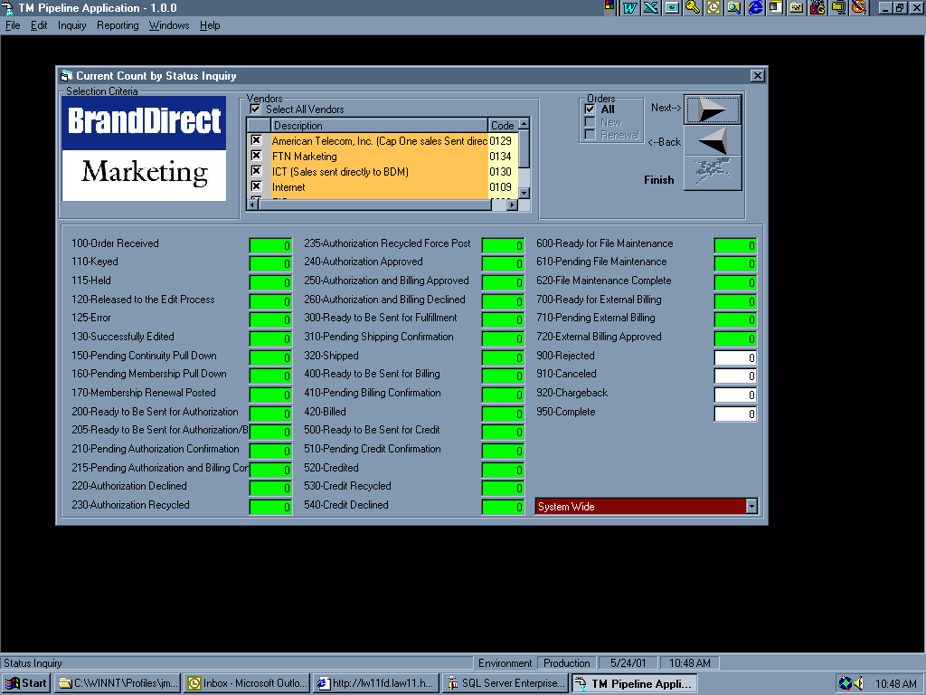

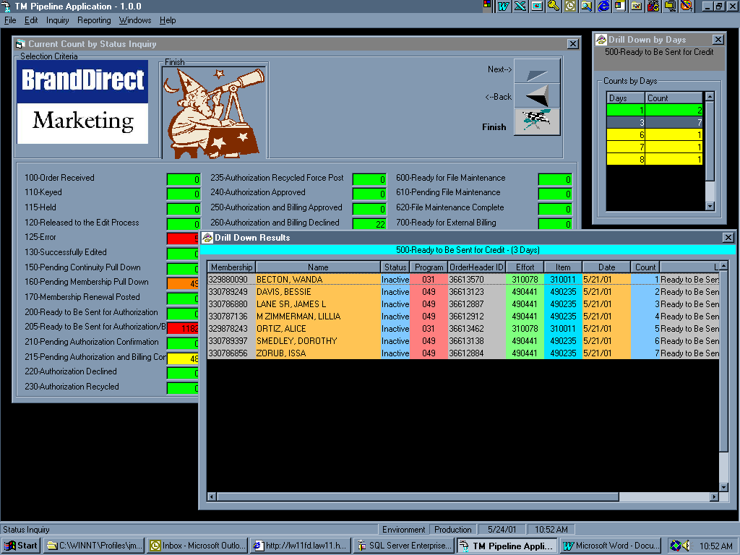
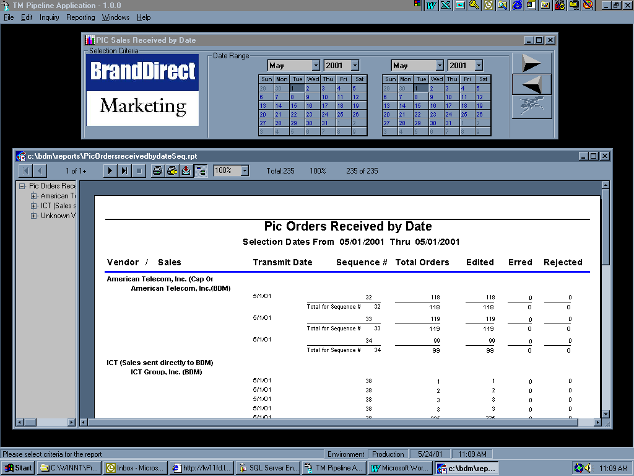

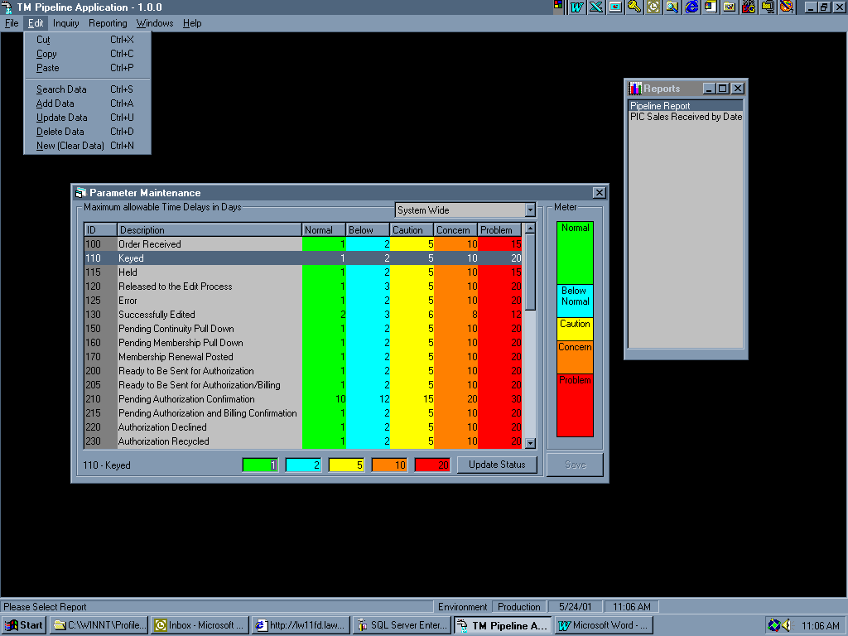

Wizard.ocx source code (Please be aware that at the time of this writing no significat error handling has been incorporated. Author - James Martin

Option Explicit
Private adoRS As New ADODB.Recordset
Private objconn As New cBDMConnection
Private adoCMD As New ADODB.Command
Private Const gintchecked = 1
Private mServer As String
Private mDataBase As String
Private mUID As String
Private mPassword As String
Private mintOption As Integer
Private mcolParameters As colParameters
Private mReportParms() As String
Private frm As Form

Public Sub Init()
Dim here As Date

cmdBack.Enabled = False
cmdNext.Enabled = True
cmdFinish.Enabled = False 'can we have this enabled all the time??

'set up the renewal frame
chkRenewal(0).Value = vbChecked
chkRenewal(0).Enabled = True
chkRenewal(1).Value = vbUnchecked
chkRenewal(2).Value = vbUnchecked
chkRenewal(1).Enabled = False
chkRenewal(2).Enabled = False
fraRenewal.Visible = False

ShowFrame fraWizard1, fraWizard1

here = Now
calStartDate.Day = 1
calStartDate.Month = Month(here)
calStartDate.Year = Year(here)
calStartDate.Refresh
calEndDate.Month = Month(here)
calEndDate.Year = Year(here)
calEndDate.Day = Day(here)
calEndDate.Refresh

'by default all option buttons are disabled
'each form/report will call this again, after init, to enable the ones that apply
Call EnableOptions("0|1|2|3|4|5|6|7|8|9|10", False)
Set frm = UserControl.Parent
Set mcolParameters = New colParameters

Def_gltTMVendors
Def_gltMatrices
Def_gltEfforts
Def_gltSeq
Def_gltClients
Def_gltClubs
Def_gltMedium
Def_gltListOwners
'Def_gltClearingCenters
'Def_gltCreditOfferers
'Def_gltManifestNumbers
End Sub
'***************************V E N D O R*********************************************
'****************************************************************************************
Private Sub Def_gltTMVendors()
Dim total_width As Integer
With gltTMVendors
.DefColCaptionFont.Size = 8
.DefFont.Size = 8
.DefColCaptionTextAlignment = gtLeftJustifyMiddle
.BackColor = &H80000001
.ColumnDefs.Add , , ""
.ColumnDefs(0).Width 400
total_width = total_width + .ColumnDefs(0).Width
.ColumnDefs(0).BackColor = RGB(190, 190, 190)

.ColumnDefs.Add , , "Description"
.ColumnDefs(1).Width 3600
total_width = total_width + .ColumnDefs(1).Width
.ColumnDefs(1).BackColor = RGB(255, 196, 84) 'Gold
'
.ColumnDefs.Add , , "Code"
.ColumnDefs(2).Width 750
total_width = total_width + .ColumnDefs(2).Width
.ColumnDefs(2).BackColor = RGB(255, 255, 190)

.ColumnDefs.Add , , "ID"
.ColumnDefs(3).Width 600
'since this is invisible we don't add to control width
.ColumnDefs(3).BackColor = RGB(127, 255, 255)
.ColumnDefs(3).Visible = False
'
'go one step further / jcm
.Top = chkAll_TMVendors.Top + chkAll_TMVendors.Height + 20
.Left = chkAll_TMVendors.Left - 75
.Width = total_width
.Height = 1600
.Enabled = False
End With
End Sub

Private Sub Get_TMVendors()
Dim strDataCommand As String
On Error Resume Next
Screen.MousePointer = vbHourglass
Select Case frm.Name
Case "frmStatusInquiry"
Select Case mintOption
Case 0, 4, 9, 10 'based on transmit date
strDataCommand = "SELECT distinct tmb.Description,tmb.BatchNumber,tmb.BusinessCode " _
& "From Poets..TMBatch tmb with(nolock) " _
& "JOIN poets..business b with(nolock) on tmb.businesscode=b.businesscode " _
& "JOIN poets..transmit tm with(nolock) ON b.businessid=tm.businessid " _
& "where tm.transmitdate between '" & Format(calStartDate.Value, "mm/dd/yyyy") _
& "' AND '" & Format(calEndDate.Value, "mm/dd/yyyy") & "' "
strDataCommand = strDataCommand & " Order by tmb.Description"
Case Else 'based on call date
strDataCommand = "SELECT distinct tmb.Description,tmb.BatchNumber,tmb.BusinessCode " _
& "From Poets..TMBatch tmb with(nolock) " _
& "join filehistory fh with(nolock) on fh.batchcode=tmb.batchnumber " _
& "where fh.calldate between '" & Format(calStartDate.Value, "mm/dd/yyyy") _
& "' AND '" & Format(calEndDate.Value, "mm/dd/yyyy") & "' "
End Select
Case Else
strDataCommand = "SELECT distinct tmb.Description,tmb.BatchNumber,tmb.BusinessCode " _
& "From Poets..TMBatch tmb with(nolock)"
strDataCommand = strDataCommand & " Order by tmb.Description"
End Select

Call Get_Build_List(strDataCommand, 3, "Loading Vendors", gltTMVendors, chkAll_TMVendors)
Exit_Sub:
Screen.MousePointer = vbDefault
End Sub

Private Sub gltTMVendors_ClickItem(ListItem As Object, SubItem As Object)
Dim strcheck As String
On Error Resume Next
strcheck = "nothing"
strcheck = SubItem.Text
If strcheck = "" Then
If ListItem.SubItems(0).Image = 1 Then
ListItem.SubItems(0).Image = 2
Else
ListItem.SubItems(0).Image = 1
End If
End If
Call Set_Command(gltTMVendors)
End Sub
Private Sub chkAll_TMVendors_Click()
Dim I As Integer
On Error Resume Next
If chkAll_TMVendors.Value = gintchecked Then
Call Set_Control_Checkbox(gltTMVendors, True)
gltTMVendors.Enabled = False
Else
Call Set_Control_Checkbox(gltTMVendors, False)
gltTMVendors.Enabled = True
End If
End Sub
'***************************M A T R I X*********************************************
'****************************************************************************************
Private Sub Def_gltMatrices()
Dim total_width As Integer
With gltMatrices
.DefColCaptionFont.Size = 8
.DefFont.Size = 8
.DefColCaptionTextAlignment = gtLeftJustifyMiddle
.BackColor = &H80000001
.ColumnDefs.Add , , ""
.ColumnDefs(0).Width 400
total_width = total_width + .ColumnDefs(0).Width
.ColumnDefs(0).BackColor = RGB(190, 190, 190)
'
.ColumnDefs.Add , , "Matrix"
.ColumnDefs(1).Width 4350
total_width = total_width + .ColumnDefs(1).Width
.ColumnDefs(1).BackColor = RGB(255, 196, 84) 'Gold

.Top = chkAll_Matrices.Top + chkAll_Matrices.Height + 20
.Left = chkAll_Matrices.Left - 75
.Width = total_width
.Height = 1600
.Enabled = False
End With
End Sub

Private Sub Get_Matrices()
Dim intCtr As Long
Dim strDataCommand As String
On Error Resume Next
Screen.MousePointer = vbHourglass
Select Case frm.Name
Case "frmStatusInquiry" 'joining on transmitdate is a cheat, but it seems to works for matrix
strDataCommand = "select Distinct me.MatrixNumber " _
& "From transmittals tr with(nolock) " _
& "JOIN poets..transmit tm with(nolock) ON tr.transmitdate=tm.transmitdate " _
& "JOIN FileHistory fh with(nolock) on tr.FileHistoryID=fh.FileHistoryID " _
& "JOIN Poets.dbo.TMBatch tmb with(nolock) ON tmb.BatchNumber=fh.BatchCode " _
& "JOIN Poets.dbo.effort eff with(nolock) ON tr.KeyCode = eff.effortNumber " _
& "JOIN Mastereffort me with(nolock) on me.effortID=eff.effortID " _
& "where tm.transmitdate between '" & Format(calStartDate.Value, "mm/dd/yyyy") _
& "' AND '" & Format(calEndDate.Value, "mm/dd/yyyy") & "' "
Select Case mintOption
Case 0 ' based on vendor
strDataCommand = strDataCommand & " AND tmb.Batchnumber in ("
intCtr = Build_SQL_CMD_line(strDataCommand, gltTMVendors, 2, True)
strDataCommand = strDataCommand & ") " & "AND ME.MatrixNumber IS NOT NULL Order by ME.MatrixNumber"
If intCtr = 0 Then GoTo Exit_Sub
Case 2 ' based on listowner
strDataCommand = strDataCommand & " AND eff.listownerbusinessid in ("
intCtr = Build_SQL_CMD_line(strDataCommand, gltClients, 3, True)
strDataCommand = strDataCommand & ") " & "AND ME.MatrixNumber IS NOT NULL Order by ME.MatrixNumber"
If intCtr = 0 Then GoTo Exit_Sub
Case Else 'in opt 6 matrix stands by itself based on date range
strDataCommand = strDataCommand & "AND ME.MatrixNumber IS NOT NULL Order by ME.MatrixNumber"
End Select
Case Else
strDataCommand = "select Distinct me.MatrixNumber " _
& "From Mastereffort me with(nolock)" _
& "where ME.MatrixNumber IS NOT NULL Order by ME.MatrixNumber"
End Select

Call Get_Build_List(strDataCommand, 1, "Loading Matrices", gltMatrices, chkAll_Matrices)

Exit_Sub:
Screen.MousePointer = vbDefault
End Sub

Private Sub gltMatrices_ClickItem(ListItem As Object, SubItem As Object)
Dim strcheck As String
On Error Resume Next
strcheck = "nothing"
strcheck = SubItem.Text
If strcheck = "" Then
If ListItem.SubItems(0).Image = 1 Then
ListItem.SubItems(0).Image = 2
Else
ListItem.SubItems(0).Image = 1
End If
End If
Call Set_Command(gltMatrices)
End Sub
Private Sub chkAll_Matrices_Click()
Dim I As Integer
On Error Resume Next
If chkAll_Matrices.Value = gintchecked Then
Call Set_Control_Checkbox(gltMatrices, True)
gltMatrices.Enabled = False
Else
Call Set_Control_Checkbox(gltMatrices, False)
gltMatrices.Enabled = True
End If
End Sub
'***************************E F F O R T S******************************************
'****************************************************************************************
Private Sub Def_gltEfforts()
Dim total_width As Integer
With gltEfforts
.DefColCaptionFont.Size = 8
.DefFont.Size = 8
.DefColCaptionTextAlignment = gtLeftJustifyMiddle
.BackColor = &H80000001
.ColumnDefs.Add , , ""
.ColumnDefs(0).Width 400
total_width = total_width + .ColumnDefs(0).Width
.ColumnDefs(0).BackColor = RGB(190, 190, 190)
'
.ColumnDefs.Add , , "Code"
.ColumnDefs(1).Width 600
total_width = total_width + .ColumnDefs(1).Width
.ColumnDefs(1).BackColor = RGB(255, 196, 84) 'Gold

.ColumnDefs.Add , , "Description"
.ColumnDefs(2).Width 3150
total_width = total_width + .ColumnDefs(2).Width
.ColumnDefs(2).BackColor = RGB(127, 200, 255) '--light blue

.ColumnDefs.Add , , "ID"
.ColumnDefs(3).Width 600
.ColumnDefs(3).Visible = False
'
.Top = chkAll_Efforts.Top + chkAll_Efforts.Height + 20
.Left = chkAll_Efforts.Left - 75
.Width = total_width
.Height = 1600
.Enabled = False
End With
End Sub

Private Sub Get_Efforts()
Dim intCtr As Long
Dim strDataCommand As String
Dim booMatrix As Boolean
On Error Resume Next

Screen.MousePointer = vbHourglass
Select Case frm.Name
Case "frmStatusInquiry"
Select Case mintOption
Case 0 'effort based on matrix and vendor
strDataCommand = "select distinct Eff.EffortNumber,Eff.Description,EFF.EffortID " _
& "From Poets..Effort EFF with(nolock) " _
& "Join MasterEffort ME with(nolock) on ME.EffortID=EFF.EffortID " _
& "Join transmittals tr with(nolock) on tr.keycode=eff.effortnumber " _
& "JOIN FileHistory fh with(nolock) on tr.FileHistoryID=fh.FileHistoryID " _
& "JOIN Poets.dbo.TMBatch tmb with(nolock) ON tmb.BatchNumber=fh.BatchCode"
If gltMatrices.ListCount > 0 Then
strDataCommand = strDataCommand & " where ME.MatrixNumber in ("
intCtr = Build_SQL_CMD_line(strDataCommand, gltMatrices, 1, True)
strDataCommand = strDataCommand & ")"
booMatrix = True
End If
If booMatrix Then
strDataCommand = strDataCommand & " and"
Else
strDataCommand = strDataCommand & " where"
End If
strDataCommand = strDataCommand & " tmb.businesscode in ("
intCtr = Build_SQL_CMD_line(strDataCommand, gltTMVendors, 3, True)
strDataCommand = strDataCommand & ") " _
& " AND ME.MatrixNumber IS NOT NULL Order by eff.effortnumber"
If Not booMatrix And intCtr = 0 Then GoTo Exit_Sub
Case 2 'effort based on matrix and listowner
strDataCommand = "select distinct Eff.EffortNumber,Eff.Description,EFF.EffortID " _
& "From Poets..Effort EFF with(nolock) " _
& "Join MasterEffort ME with(nolock) on ME.EffortID=EFF.EffortID " _
& "Join transmittals tr with(nolock) on tr.keycode=eff.effortnumber " _
& "JOIN FileHistory fh with(nolock) on tr.FileHistoryID=fh.FileHistoryID " _
& "JOIN Poets.dbo.TMBatch tmb with(nolock) ON tmb.BatchNumber=fh.BatchCode"
If gltMatrices.ListCount > 0 Then
strDataCommand = strDataCommand & " where ME.MatrixNumber in ("
intCtr = Build_SQL_CMD_line(strDataCommand, gltMatrices, 1, True)
strDataCommand = strDataCommand & ")"
booMatrix = True
End If
If booMatrix Then
strDataCommand = strDataCommand & " and"
Else
strDataCommand = strDataCommand & " where"
End If
strDataCommand = strDataCommand & " eff.listownerbusinessid in ("
intCtr = Build_SQL_CMD_line(strDataCommand, gltListOwners, 3, True)
strDataCommand = strDataCommand & ") " _
& " AND ME.MatrixNumber IS NOT NULL Order by eff.effortnumber"
If Not booMatrix And intCtr = 0 Then GoTo Exit_Sub

Case 1, 9 'effort based on club(marketingprogramid)
strDataCommand = "select Eff.EffortNumber,Eff.Description,EFF.EffortID " _
& "From poets..marketingprogram mp with(nolock) " _
& "Join Poets..Effort EFF with(nolock) on mp.marketingprogramid=eff.marketingprogramid " _
& "where mp.marketingprogramid in ("
intCtr = Build_SQL_CMD_line(strDataCommand, gltClubs, 2, True)
If intCtr = 0 Then GoTo Exit_Sub
strDataCommand = strDataCommand & ") "
End Select
Case Else
strDataCommand = "select distinct Eff.EffortNumber,Eff.Description,EFF.EffortID " _
& "From Poets..Effort EFF with(nolock)"
End Select
Call Get_Build_List(strDataCommand, 2, "Loading Efforts", gltEfforts, chkAll_Efforts)
Exit_Sub:
Screen.MousePointer = vbDefault
End Sub

Private Sub gltEfforts_ClickItem(ListItem As Object, SubItem As Object)
Dim strcheck As String
On Error Resume Next
strcheck = "nothing"
strcheck = SubItem.Text
If strcheck = "" Then
If ListItem.SubItems(0).Image = 1 Then
ListItem.SubItems(0).Image = 2
Else
ListItem.SubItems(0).Image = 1
End If
End If
Call Set_Command(gltEfforts)
End Sub

Private Sub chkAll_Efforts_Click()
Dim I As Integer
On Error Resume Next
If chkAll_Efforts.Value = gintchecked Then
Call Set_Control_Checkbox(gltEfforts, True)
gltEfforts.Enabled = False
Else
Call Set_Control_Checkbox(gltEfforts, False)
gltEfforts.Enabled = True
End If
End Sub
'***************************S E Q U E N C E***************************************
'****************************************************************************************
Private Sub Def_gltSeq()
Dim total_width As Integer
With gltSeq
.DefColCaptionFont.Size = 8
.DefFont.Size = 8
.DefColCaptionTextAlignment = gtLeftJustifyMiddle
.BackColor = &H80000001
'
.ColumnDefs.Add , , ""
.ColumnDefs(0).Width 400
total_width = total_width + .ColumnDefs(0).Width
.ColumnDefs(0).BackColor = RGB(190, 190, 190) '--Gray
'
.ColumnDefs.Add , , "Sequence #'s"
.ColumnDefs(1).Width 3750
total_width = total_width + .ColumnDefs(1).Width
.ColumnDefs(1).BackColor = RGB(90, 190, 190) '--Teal

.ColumnDefs.Add , , "ID"
.ColumnDefs(2).Width 600
.ColumnDefs(2).Visible = False
'
.Top = chkAll_Seq.Top + chkAll_Seq.Height + 20
.Left = chkAll_Seq.Left - 75
.Width = total_width
.Height = 1600
.Enabled = False
End With
End Sub

Private Sub Get_Seq()
Dim intCtr As Long
Dim strDataCommand As String
On Error Resume Next
Screen.MousePointer = vbHourglass
strDataCommand = "select Distinct tm.sequencenumber " _
& "from poets..transmit tm with(nolock) " _
& "join poets..business b with(nolock) on tm.businessid=b.businessid " _
& "join poets..tmbatch tmb with(nolock) on tmb.businesscode=b.businesscode " _
& "where tmb.businesscode in ("
intCtr = Build_SQL_CMD_line(strDataCommand, gltTMVendors, 3, True)
If intCtr = 0 Then GoTo Exit_Sub
strDataCommand = strDataCommand & ") order by tm.sequencenumber"
Call Get_Build_List(strDataCommand, 1, "Loading Seq", gltSeq, chkAll_Seq)
Exit_Sub:
Screen.MousePointer = vbDefault
End Sub

Private Sub gltSeq_ClickItem(ListItem As Object, SubItem As Object)
Dim strcheck As String
On Error Resume Next
strcheck = "nothing"
strcheck = SubItem.Text
If strcheck = "" Then
If ListItem.SubItems(0).Image = 1 Then
ListItem.SubItems(0).Image = 2
Else
ListItem.SubItems(0).Image = 1
End If
End If
Call Set_Command(gltSeq)
End Sub
Private Sub chkAll_Seq_Click()
Dim I As Integer
On Error Resume Next
If chkAll_Seq.Value = gintchecked Then
Call Set_Control_Checkbox(gltSeq, True)
gltSeq.Enabled = False
Else
Call Set_Control_Checkbox(gltSeq, False)
gltSeq.Enabled = True
End If
End Sub
'***************************M E D I U M *******************************************
'****************************************************************************************
Private Sub Def_gltMedium()
Dim total_width As Integer
With gltMedium
.DefColCaptionFont.Size = 8
.DefFont.Size = 8
.DefColCaptionTextAlignment = gtLeftJustifyMiddle
.BackColor = &H80000001
'
.ColumnDefs.Add , , ""
.ColumnDefs(0).Width 400
total_width = total_width + .ColumnDefs(0).Width
.ColumnDefs(0).BackColor = RGB(190, 190, 190)
'
.ColumnDefs.Add , , "Description"
.ColumnDefs(1).Width 3450
total_width = total_width + .ColumnDefs(1).Width
.ColumnDefs(1).BackColor = RGB(127, 255, 255)

.ColumnDefs.Add , , "ID"
.ColumnDefs(2).Width 600
.ColumnDefs(2).BackColor = RGB(127, 255, 255)
.ColumnDefs(2).Visible = False
'
.Top = chkAll_Medium.Top + chkAll_Medium.Height + 20
.Left = chkAll_Medium.Left - 75
.Width = total_width
.Height = 1600
.Enabled = False
End With
End Sub
Private Sub get_Medium()
Dim intCtr As Long
Dim strDataCommand As String
On Error Resume Next
Screen.MousePointer = vbHourglass
strDataCommand = "select distinct med.description,med.mediumid " _
& "from Poets..Medium med with(nolock) " _
& "where med.description is not null"

Call Get_Build_List(strDataCommand, 3, "Loading Medium", gltMedium, chkAll_Medium)
Exit_Sub:
Screen.MousePointer = vbDefault
End Sub
Private Sub gltMedium_ClickItem(ListItem As Object, SubItem As Object)
Dim strcheck As String
On Error Resume Next
strcheck = "nothing"
strcheck = SubItem.Text
If strcheck = "" Then
If ListItem.SubItems(0).Image = 1 Then
ListItem.SubItems(0).Image = 2
Else
ListItem.SubItems(0).Image = 1
End If
End If
Call Set_Command(gltMedium)
End Sub
Private Sub chkAll_Medium_Click()
Dim I As Integer
On Error Resume Next
If chkAll_Medium.Value = gintchecked Then
Call Set_Control_Checkbox(gltMedium, True)
gltMedium.Enabled = False
Else
Call Set_Control_Checkbox(gltMedium, False)
gltMedium.Enabled = True
End If
End Sub
'***************************C L U B S ** *******************************************
'****************************************************************************************
Private Sub Def_gltClubs()
Dim total_width As Integer
With gltClubs
.DefColCaptionFont.Size = 8
.DefFont.Size = 8
.DefColCaptionTextAlignment = gtLeftJustifyMiddle
.BackColor = &H80000001
.ColumnDefs.Add , , ""
.ColumnDefs(0).Width 400
total_width = .ColumnDefs(0).Width
.ColumnDefs(0).BackColor = RGB(190, 190, 190)
'
.ColumnDefs.Add , , "Description"
.ColumnDefs(1).Width 3100
total_width = total_width + .ColumnDefs(1).Width
.ColumnDefs(1).BackColor = RGB(127, 200, 255) '--light blue

.ColumnDefs.Add , , "ID"
.ColumnDefs(2).Width 600
.ColumnDefs(2).Visible = False
'
.Top = chkAll_Clubs.Top + chkAll_Clubs.Height + 20
.Left = chkAll_Clubs.Left - 75
.Width = total_width
.Height = 1600
.Enabled = False
End With
End Sub
Private Sub get_Clubs()
Dim intCtr As Long
Dim strDataCommand As String
On Error Resume Next
Screen.MousePointer = vbHourglass
Select Case frm.Name
Case "frmStatuInquiry" 'club based on medium
strDataCommand = "select distinct mp.description,mp.marketingprogramid " _
& "from Poets..marketingprogram mp with(nolock) " _
& "join Poets..effort eff with(nolock) on mp.marketingprogramid=eff.marketingprogramid " _
& "join Poets..medium med with(nolock) on eff.mediumid=med.mediumid " _
& "where med.mediumid in ("
intCtr = Build_SQL_CMD_line(strDataCommand, gltMedium, 2, True)
strDataCommand = strDataCommand & ")"
If intCtr = 0 Then GoTo Exit_Sub
Case Else
strDataCommand = "select distinct mp.description,mp.marketingprogramid " _
& "from Poets..marketingprogram mp with(nolock)"
End Select
Call Get_Build_List(strDataCommand, 2, "Loading Clubs", gltClubs, chkAll_Clubs)
Exit_Sub:
Screen.MousePointer = vbDefault
End Sub
Private Sub gltClubs_ClickItem(ListItem As Object, SubItem As Object)
Dim strcheck As String
On Error Resume Next
strcheck = "nothing"
strcheck = SubItem.Text
If strcheck = "" Then
If ListItem.SubItems(0).Image = 1 Then
ListItem.SubItems(0).Image = 2
Else
ListItem.SubItems(0).Image = 1
End If
End If
Call Set_Command(gltClubs)
End Sub
Private Sub chkAll_Clubs_Click()
Dim I As Integer
On Error Resume Next
If chkAll_Clubs.Value = gintchecked Then
Call Set_Control_Checkbox(gltClubs, True)
gltClubs.Enabled = False
Else
Call Set_Control_Checkbox(gltClubs, False)
gltClubs.Enabled = True
End If
End Sub

'***************************C L I E N T S*****************************************
'****************************************************************************************
Private Sub Def_gltClients()
Dim total_width As Integer
With gltClients
.DefColCaptionFont.Size = 8
.DefFont.Size = 8
.DefColCaptionTextAlignment = gtLeftJustifyMiddle
.BackColor = &H80000001
'
.ColumnDefs.Add , , ""
.ColumnDefs(0).Width 400
total_width = total_width + .ColumnDefs(0).Width
.ColumnDefs(0).BackColor = RGB(190, 190, 190) '--Gray
'
.ColumnDefs.Add , , "Description"
.ColumnDefs(1).Width 3750
total_width = total_width + .ColumnDefs(1).Width
.ColumnDefs(1).BackColor = RGB(90, 190, 190) '--Teal

.ColumnDefs.Add , , "ParentID"
.ColumnDefs(2).Width 600
.ColumnDefs(2).Visible = False

.ColumnDefs.Add , , "ListOwner"
.ColumnDefs(3).Width 600
.ColumnDefs(3).Visible = False
'
.Top = chkAll_Clients.Top + chkAll_Clients.Height + 20
.Left = chkAll_Clients.Left - 75
.Width = total_width
.Height = 1600
.Enabled = False
End With
End Sub
Private Sub get_Clients()
Dim intCtr As Long
Dim strDataCommand As String
On Error Resume Next
Screen.MousePointer = vbHourglass
strDataCommand = "select distinct pc.parentname,pc.parentid,pb.businessid " _
& "From parentclient pc with(nolock) " _
& "join parentbusiness pb with(nolock) on pc.parentid=pb.parentid " _
& "order by pc.parentname"
Call Get_Build_List(strDataCommand, 3, "Loading Clients", gltClients, chkAll_Clients)
Exit_Sub:
Screen.MousePointer = vbDefault
End Sub
Private Sub gltClients_ClickItem(ListItem As Object, SubItem As Object)
Dim strcheck As String
On Error Resume Next
strcheck = "nothing"
strcheck = SubItem.Text
If strcheck = "" Then
If ListItem.SubItems(0).Image = 1 Then
ListItem.SubItems(0).Image = 2
Else
ListItem.SubItems(0).Image = 1
End If
End If
Call Set_Command(gltClients)
End Sub
Private Sub chkAll_Clients_Click()
Dim I As Integer
On Error Resume Next
If chkAll_Clients.Value = gintchecked Then
Call Set_Control_Checkbox(gltClients, True)
gltClients.Enabled = False
Else
Call Set_Control_Checkbox(gltClients, False)
gltClients.Enabled = True
End If
End Sub

'***************************L I S T O W N E R************************************
'****************************************************************************************
Private Sub Def_gltListOwners()
Dim total_width As Integer
With gltListOwners
.DefColCaptionFont.Size = 8
.DefFont.Size = 8
.DefColCaptionTextAlignment = gtLeftJustifyMiddle
.BackColor = &H80000001
'
.ColumnDefs.Add , , ""
.ColumnDefs(0).Width 400
total_width = total_width + .ColumnDefs(0).Width
.ColumnDefs(0).BackColor = RGB(190, 190, 190)
'
.ColumnDefs.Add , , "Code"
.ColumnDefs(1).Width 600
total_width = total_width + .ColumnDefs(1).Width
.ColumnDefs(1).BackColor = RGB(255, 255, 190)

.ColumnDefs.Add , , "Description"
.ColumnDefs(2).Width 2400
total_width = total_width + .ColumnDefs(2).Width
.ColumnDefs(2).BackColor = RGB(127, 255, 255)

.ColumnDefs.Add , , "ID"
.ColumnDefs(3).Width 600
.ColumnDefs(3).BackColor = RGB(127, 255, 255)
.ColumnDefs(3).Visible = False
'
.Top = chkAll_ListOwners.Top + chkAll_ListOwners.Height + 20
.Left = chkAll_ListOwners.Left - 75
.Width = total_width
.Height = 1600
.Enabled = False
End With
End Sub
Private Sub get_ListOwners()
Dim intCtr As Long
Dim strDataCommand As String
On Error Resume Next
Screen.MousePointer = vbHourglass
Select Case frm.Name
Case "frmStatusInquiry"
strDataCommand = "select Distinct B.BusinessCode,B.BusinessName,B.BusinessID " _
& "From parentclient pc with(nolock) " _
& "Join parentbusiness pb with(nolock) on pc.parentid=pb.parentid " _
& "Join poets..Business B with(nolock) on B.BusinessID=pb.BusinessID " _
& "where pc.parentid in ("
intCtr = Build_SQL_CMD_line(strDataCommand, gltClients, 2, False)
If intCtr = 0 Then GoTo Exit_Sub
strDataCommand = strDataCommand & ") order by B.BusinessName"
Case Else
strDataCommand = "select Distinct B.BusinessCode,B.BusinessName,B.BusinessID " _
& "from poets..Business B with(nolock) " _
& "Join poets..Businessrole br with(nolock) on Br.Businessid=b.Businessid " _
& "where br.businesstypeid=2"
End Select

Call Get_Build_List(strDataCommand, 2, "Loading ListOwners", _
gltListOwners, chkAll_ListOwners)

Exit_Sub:
Screen.MousePointer = vbDefault
End Sub
Private Sub gltListowners_ClickItem(ListItem As Object, SubItem As Object)
Dim strcheck As String
On Error Resume Next
strcheck = "nothing"
strcheck = SubItem.Text
If strcheck = "" Then
If ListItem.SubItems(0).Image = 1 Then
ListItem.SubItems(0).Image = 2
Else
ListItem.SubItems(0).Image = 1
End If
End If
Call Set_Command(gltListOwners)
End Sub
Private Sub chkAll_ListOwners_Click()
Dim I As Integer
On Error Resume Next
If chkAll_ListOwners.Value = gintchecked Then
Call Set_Control_Checkbox(gltListOwners, True)
gltListOwners.Enabled = False
Else
Call Set_Control_Checkbox(gltListOwners, False)
gltListOwners.Enabled = True
End If
End Sub
'***************************C L E A R I N G C E N T E R******************
'****************************************************************************************
'***************************C R E D I T O F F E R E R E R***************
'****************************************************************************************
'***************************M A N I F E S T N U M B E R******************
'****************************************************************************************

Private Sub cmdNext_Click()
Call GoNext
If Not fraWizard1.Visible And _
Not fraFinish.Visible And _
Not fraDate.Visible Then
fraRenewal.Visible = True
Else
fraRenewal.Visible = False
End If
End Sub
Private Sub cmdBack_Click()
Call GoBack
If Not fraWizard1.Visible And _
Not fraFinish.Visible And _
Not fraDate.Visible Then
fraRenewal.Visible = True
Else
fraRenewal.Visible = False
End If
End Sub
Private Sub chkRenewal_Click(Index As Integer)
If chkRenewal(0).Value = vbUnchecked And chkRenewal(0).Enabled Then
chkRenewal(0).Enabled = False
chkRenewal(1).Enabled = True
chkRenewal(2).Enabled = True
chkRenewal(1).Value = vbUnchecked
chkRenewal(2).Value = vbUnchecked
ElseIf chkRenewal(1).Value = vbChecked And chkRenewal(2).Value = vbChecked Then
chkRenewal(0).Enabled = True
chkRenewal(0).Value = vbChecked
chkRenewal(1).Value = vbUnchecked
chkRenewal(2).Value = vbUnchecked
chkRenewal(1).Enabled = False
chkRenewal(2).Enabled = False
End If
End Sub

Private Sub optWizard_Click(Index As Integer)
cmdNext.Enabled = True
mintOption = Index
End Sub

Private Sub cmdFinish_Click()
Dim I As Integer
Dim strMatrices$, strEfforts$, strSeqNumbers$, strTMVendors$, retval%
Dim strClients$, strClubs$, strListOwners$, strMediums$
Dim cParm As cParameter, x%

Screen.MousePointer = 13

Select Case frm.Name
Case "frmStatusInquiry"

Set cParm = New cParameter
cParm.Name = "@startdate"
cParm.Value = Format(calStartDate.Value, "mm/dd/yyyy")
mcolParameters.Add cParm
Set cParm = Nothing

Set cParm = New cParameter
cParm.Name = "@enddate"
cParm.Value = Format(calEndDate.Value, "mm/dd/yyyy")
mcolParameters.Add cParm
Set cParm = Nothing

'******************************mintoption(index)
'option 0=transmitdate,vendor, matrix, effort, sequence #
'option 1=call date,medium, club, effort
'option 2=call date,client, listowner, matrix, effort
'option 3=call date,client
'option 4=transmitdate,vendor, sequence #
'option 5=call date,credit offerer
'option 6=call date,matrix
'option 7=call date,clearing center
'option 8=call date,manifest number
'option 9=transmitdate,medium, club, effort
'option 10=transmitdate,vendor

Set cParm = New cParameter
cParm.Name = "@tmvendors"
cParm.Value = ""
If chkAll_TMVendors.Value = 0 And mintOption = 0 Then
retval = Build_SP_Cmd_Line(strTMVendors, gltTMVendors, 3)
cParm.Value = strTMVendors
End If
mcolParameters.Add cParm

Set cParm = New cParameter
cParm.Name = "@matrices"
cParm.Value = ""
If chkAll_Matrices.Value = 0 And _
(mintOption = 0 Or mintOption = 2 Or mintOption = 6) Then
retval = Build_SP_Cmd_Line(strMatrices, gltMatrices, 1)
cParm.Value = strMatrices
End If
mcolParameters.Add cParm
Set cParm = Nothing

Set cParm = New cParameter
cParm.Name = "@efforts"
cParm.Value = ""
If chkAll_Efforts.Value = 0 And _
(mintOption = 0 Or mintOption = 1 Or mintOption = 2 Or mintOption = 9) Then
retval = Build_SP_Cmd_Line(strEfforts, gltEfforts, 1)
cParm.Value = strEfforts
End If
mcolParameters.Add cParm

Set cParm = New cParameter
cParm.Name = "@seqnumbers"
cParm.Value = ""
If chkAll_Seq.Value = 0 And (mintOption = 0 Or mintOption = 4) Then
retval = Build_SP_Cmd_Line(strSeqNumbers, gltSeq, 1)
cParm.Value = strSeqNumbers
End If
mcolParameters.Add cParm
Set cParm = Nothing

Set cParm = Nothing
Set cParm = New cParameter
cParm.Name = "@clients"
cParm.Value = ""
If chkAll_Clients.Value = 0 And (mintOption = 2 Or mintOption = 3) Then
retval = Build_SP_Cmd_Line(strClients, gltClients, 2)
cParm.Value = strClients
End If
mcolParameters.Add cParm
Set cParm = Nothing

Set cParm = New cParameter
cParm.Name = "@listowners"
cParm.Value = ""
If chkAll_ListOwners.Value = 0 And mintOption = 2 Then
retval = Build_SP_Cmd_Line(strListOwners, gltListOwners, 3) '2 for business code
cParm.Value = strListOwners
End If
mcolParameters.Add cParm
Set cParm = Nothing

Set cParm = New cParameter
cParm.Name = "@clubs"
cParm.Value = ""
If chkAll_Clubs.Value = 0 And (mintOption = 1 Or mintOption = 9) Then
retval = Build_SP_Cmd_Line(strClubs, gltClubs, 2)
cParm.Value = strClubs
End If
mcolParameters.Add cParm
Set cParm = Nothing

Set cParm = New cParameter
cParm.Name = "@mediums"
cParm.Value = ""
If chkAll_Clubs.Value = 0 And (mintOption = 1 Or mintOption = 9) Then
retval = Build_SP_Cmd_Line(strMediums, gltMedium, 2)
cParm.Value = strMediums
End If
mcolParameters.Add cParm
Set cParm = Nothing
'add check all logic
'******************************
Set cParm = New cParameter
cParm.Name = "@creditofferers"
cParm.Value = ""
mcolParameters.Add cParm
Set cParm = Nothing

Set cParm = New cParameter
cParm.Name = "@clearingcenters"
cParm.Value = ""
mcolParameters.Add cParm
Set cParm = Nothing

Set cParm = New cParameter
cParm.Name = "@manifestnumbers"
cParm.Value = ""
mcolParameters.Add cParm
Set cParm = Nothing
'******************************
'this parameter corresponds to the index of the selected option button
Set cParm = New cParameter
cParm.Name = "@options"
cParm.Value = mintOption
mcolParameters.Add cParm
Set cParm = Nothing

Set cParm = New cParameter
cParm.Name = "@renewal"
cParm.Value = ""
If chkRenewal(0).Value = vbChecked Then
cParm.Value = 0
ElseIf chkRenewal(1).Value = vbChecked Then
cParm.Value = 1
ElseIf chkRenewal(2).Value = vbChecked Then
cParm.Value = 2
End If
mcolParameters.Add cParm
Set cParm = Nothing
Case "frmGeneralReport" 'in this case parameter names were already populated from the form
'we simply need to assign their values
'below is for pic orders received by data
'follow this format
For x = 1 To mcolParameters.Count
Set cParm = New cParameter
Set cParm = mcolParameters.Item(x)
Select Case cParm.Name
Case "@StartDate"
cParm.Value = Format(calStartDate.Value, "mm/dd/yyyy")
Case "@EndDate"
cParm.Value = Format(calEndDate.Value, "mm/dd/yyyy")
Case "@TMVendors"
If chkAll_TMVendors.Value = 0 Then
retval = Build_SP_Cmd_Line(strTMVendors, gltTMVendors, 3)
cParm.Value = strTMVendors
Else
'since these are not repopulated each time we need to set to
'nothing if the user goes back and selects all
cParm.Value = ""
End If
Case "@SeqNumbers"
If chkAll_Seq.Value = 0 Then
retval = Build_SP_Cmd_Line(strSeqNumbers, gltSeq, 1)
cParm.Value = strSeqNumbers
Else
cParm.Value = ""
End If
End Select
Next x
End Select

'these work and are enabled for status form and test report
If mintOption = 0 Or mintOption = 4 Or mintOption = 9 Or mintOption = 10 Then
Select Case frm.Name
Case "frmStatusInquiry"
Show_Progress ("Loading Data")
Call frm.LoadData
Show_Progress ("Distributing Counts")
Call frm.LoadCounts
Hide_Progress
For x = mcolParameters.Count To 1 Step -1
Call mcolParameters.Remove(x)
Next x
Case "frmGeneralReport"
Call frm.finish
End Select
Else 'the rest are still under development
Dim strout$, retval2#
Clipboard.Clear
For x = 1 To mcolParameters.Count
Set cParm = mcolParameters.Item(x)
strout = strout & cParm.Name & vbTab & cParm.Value & vbCrLf
Next x
strout = strout & "----------------------------------------"
Call Clipboard.SetText(strout)
Set cParm = Nothing
retval2 = Shell("Notepad", vbNormalFocus)
AppActivate retval2
SendKeys "+{INSERT}", True
For x = mcolParameters.Count To 1 Step -1
Call mcolParameters.Remove(x)
Next x
End If

Screen.MousePointer = 0

End Sub

Private Sub GoNext()
If optWizard(0).Value = True Then
Set_Opt0_Forward
ElseIf optWizard(1).Value = True Then
Set_Opt1_Forward
ElseIf optWizard(2).Value = True Then
Set_Opt2_Forward
ElseIf optWizard(3).Value = True Then
Set_Opt3_Forward
ElseIf optWizard(4).Value = True Then
Set_Opt4_Forward
ElseIf optWizard(5).Value = True Then
'Set_Opt5_Forward
ElseIf optWizard(6).Value = True Then
Set_Opt6_Forward
ElseIf optWizard(7).Value = True Then
'Set_Opt7_Forward
ElseIf optWizard(8).Value = True Then
'Set_Opt8_Forward
ElseIf optWizard(9).Value = True Then
Set_Opt9_Forward
ElseIf optWizard(10).Value = True Then
Set_Opt10_Forward
End If
End Sub

Private Sub GoBack()
If optWizard(0).Value = True Then
Set_Opt0_Backward
ElseIf optWizard(1).Value = True Then
Set_Opt1_Backward
ElseIf optWizard(2).Value = True Then
Set_Opt2_Backward
ElseIf optWizard(3).Value = True Then
Set_Opt3_Backward
ElseIf optWizard(4).Value = True Then
Set_Opt4_Backward
ElseIf optWizard(5).Value = True Then
'Set_Opt5_Backward
ElseIf optWizard(6).Value = True Then
Set_Opt6_Backward
ElseIf optWizard(7).Value = True Then
'Set_Opt7_Backward
ElseIf optWizard(8).Value = True Then
'Set_Opt8_Backward
ElseIf optWizard(9).Value = True Then
Set_Opt9_Backward
ElseIf optWizard(10).Value = True Then
Set_Opt10_Backward
End If

End Sub

Private Sub Set_Opt0_Forward()
If fraWizard1.Visible = True Then
Call ShowFrame(fraDate, fraWizard1)
cmdBack.Enabled = True
ElseIf fraDate.Visible = True Then
Call ShowFrame(fraVendors, fraDate)
Call Get_TMVendors
ElseIf fraVendors.Visible = True Then
Call ShowFrame(fraMatrix, fraVendors)
Call Get_Matrices
ElseIf fraMatrix.Visible = True Then
Call ShowFrame(fraEfforts, fraMatrix)
Call Get_Efforts
ElseIf fraEfforts.Visible = True Then
Call ShowFrame(fraSeq, fraEfforts)
Call Get_Seq
ElseIf fraSeq.Visible = True Then
Call ShowFrame(fraFinish, fraSeq)
cmdNext.Enabled = False
cmdFinish.Enabled = True
End If
End Sub
Private Sub Set_Opt0_Backward()
If fraDate.Visible = True Then
Call ShowFrame(fraWizard1, fraDate)
cmdBack.Enabled = False
ElseIf fraVendors.Visible = True Then
Call ShowFrame(fraDate, fraVendors)
cmdNext.Enabled = True
ElseIf fraMatrix.Visible = True Then
Call ShowFrame(fraVendors, fraMatrix)
cmdNext.Enabled = True
ElseIf fraEfforts.Visible = True Then
Call ShowFrame(fraMatrix, fraEfforts)
cmdNext.Enabled = True
ElseIf fraSeq.Visible = True Then
Call ShowFrame(fraEfforts, fraSeq)
cmdNext.Enabled = True
ElseIf fraFinish.Visible = True Then
Call ShowFrame(fraSeq, fraFinish)
cmdNext.Enabled = True
cmdFinish.Enabled = False
End If
End Sub

Private Sub Set_Opt1_Forward()
If fraWizard1.Visible = True Then
Call ShowFrame(fraDate, fraWizard1)
cmdBack.Enabled = True
ElseIf fraDate.Visible = True Then
Call ShowFrame(fraMedium, fraDate)
get_Medium
ElseIf fraMedium.Visible = True Then
Call ShowFrame(fraClubs, fraMedium)
get_Clubs
ElseIf fraClubs.Visible = True Then
Call ShowFrame(fraEfforts, fraClubs)
Get_Efforts
ElseIf fraEfforts.Visible = True Then
Call ShowFrame(fraFinish, fraEfforts)
cmdNext.Enabled = False
cmdFinish.Enabled = True
End If
End Sub
Private Sub Set_Opt1_Backward()
If fraDate.Visible = True Then
Call ShowFrame(fraWizard1, fraDate)
cmdBack.Enabled = False
cmdNext.Enabled = True
ElseIf fraMedium.Visible = True Then
Call ShowFrame(fraDate, fraMedium)
cmdNext.Enabled = True
ElseIf fraClubs.Visible = True Then
Call ShowFrame(fraMedium, fraClubs)
cmdNext.Enabled = True
ElseIf fraEfforts.Visible = True Then
Call ShowFrame(fraClubs, fraEfforts)
cmdNext.Enabled = True
ElseIf fraFinish.Visible = True Then
Call ShowFrame(fraEfforts, fraFinish)
cmdNext.Enabled = True
cmdFinish.Enabled = False
End If
End Sub

Private Sub Set_Opt2_Forward()
If fraWizard1.Visible = True Then
Call ShowFrame(fraDate, fraWizard1)
cmdBack.Enabled = True
ElseIf fraDate.Visible = True Then
Call ShowFrame(fraClients, fraDate)
get_Clients
ElseIf fraClients.Visible = True Then
Call ShowFrame(fraListOwners, fraClients)
get_ListOwners
ElseIf fraListOwners.Visible = True Then
Call ShowFrame(fraMatrix, fraListOwners)
Get_Matrices
ElseIf fraMatrix.Visible = True Then
Call ShowFrame(fraEfforts, fraMatrix)
Get_Efforts
ElseIf fraEfforts.Visible = True Then
Call ShowFrame(fraFinish, fraEfforts)
cmdNext.Enabled = False
cmdFinish.Enabled = True
End If
End Sub
Private Sub Set_Opt2_Backward()
If fraDate.Visible = True Then
Call ShowFrame(fraWizard1, fraDate)
cmdBack.Enabled = False
cmdNext.Enabled = True
ElseIf fraClients.Visible = True Then
Call ShowFrame(fraDate, fraClients)
cmdNext.Enabled = True
ElseIf fraListOwners.Visible = True Then
Call ShowFrame(fraClients, fraListOwners)
cmdNext.Enabled = True
ElseIf fraMatrix.Visible = True Then
Call ShowFrame(fraListOwners, fraMatrix)
cmdNext.Enabled = True
ElseIf fraEfforts.Visible = True Then
Call ShowFrame(fraMatrix, fraEfforts)
cmdNext.Enabled = True
ElseIf fraFinish.Visible = True Then
Call ShowFrame(fraEfforts, fraFinish)
cmdNext.Enabled = True
cmdFinish.Enabled = False
End If
End Sub
Private Sub Set_Opt3_Forward()
If fraWizard1.Visible = True Then
Call ShowFrame(fraDate, fraWizard1)
cmdBack.Enabled = True
ElseIf fraDate.Visible = True Then
Call ShowFrame(fraClients, fraDate)
get_Clients
ElseIf fraClients.Visible = True Then
Call ShowFrame(fraFinish, fraClients)
cmdNext.Enabled = False
cmdFinish.Enabled = True
End If
End Sub
Private Sub Set_Opt3_Backward()
If fraDate.Visible = True Then
Call ShowFrame(fraWizard1, fraDate)
cmdBack.Enabled = False
cmdNext.Enabled = True
ElseIf fraClients.Visible = True Then
Call ShowFrame(fraDate, fraClients)
cmdNext.Enabled = True
ElseIf fraFinish.Visible = True Then
Call ShowFrame(fraClients, fraFinish)
cmdNext.Enabled = True
cmdFinish.Enabled = False
End If
End Sub
Private Sub Set_Opt4_Forward()
If fraWizard1.Visible = True Then
Call ShowFrame(fraDate, fraWizard1)
cmdBack.Enabled = True
ElseIf fraDate.Visible = True Then
Call ShowFrame(fraVendors, fraDate)
Call Get_TMVendors
ElseIf fraVendors.Visible = True Then
Call ShowFrame(fraSeq, fraVendors)
Get_Seq
ElseIf fraSeq.Visible = True Then
Call ShowFrame(fraFinish, fraSeq)
cmdNext.Enabled = False
cmdFinish.Enabled = True
End If
End Sub
Private Sub Set_Opt4_Backward()
If fraDate.Visible = True Then
Call ShowFrame(fraWizard1, fraDate)
cmdBack.Enabled = False
cmdNext.Enabled = True
ElseIf fraVendors.Visible = True Then
Call ShowFrame(fraDate, fraVendors)
cmdNext.Enabled = True
ElseIf fraSeq.Visible = True Then
Call ShowFrame(fraVendors, fraSeq)
cmdNext.Enabled = True
ElseIf fraFinish.Visible = True Then
Call ShowFrame(fraSeq, fraFinish)
cmdNext.Enabled = True
cmdFinish.Enabled = False
End If
End Sub

'Private Sub Set_Opt5_Forward()
' If fraWizard1.Visible = True Then
' Call ShowFrame(fraDate, fraWizard1)
' cmdBack.Enabled = True
' ElseIf fraDate.Visible = True Then
' Call ShowFrame(fraCreditOfferer, fraDate)
' ElseIf fraCreditOfferer.Visible = True Then
' Call ShowFrame(fraFinish, fraCreditOfferer)
' cmdNext.Enabled = False
' cmdFinish.Enabled = True
' End If
'End Sub
'Private Sub Set_Opt5_Backward()
' If fraDate.Visible = True Then
' Call ShowFrame(fraWizard1, fraDate)
' cmdBack.Enabled = False
' cmdNext.Enabled = True
' ElseIf fraCreditOfferer.Visible = True Then
' Call ShowFrame(fraCreditOfferer, fraDate)
' cmdNext.Enabled = True
' ElseIf fraFinish.Visible = True Then
' Call ShowFrame(fraCreditOfferer, fraFinish)
' cmdNext.Enabled = True
' cmdFinish.Enabled = False
' End If
'End Sub
Private Sub Set_Opt6_Forward()
If fraWizard1.Visible = True Then
Call ShowFrame(fraDate, fraWizard1)
cmdBack.Enabled = True
ElseIf fraDate.Visible = True Then
Call ShowFrame(fraMatrix, fraDate)
Get_Matrices
cmdNext.Enabled = True
ElseIf fraMatrix.Visible = True Then
Call ShowFrame(fraFinish, fraMatrix)
cmdNext.Enabled = False
cmdFinish.Enabled = True
End If
End Sub
Private Sub Set_Opt6_Backward()
If fraDate.Visible = True Then
Call ShowFrame(fraWizard1, fraDate)
cmdBack.Enabled = False
cmdNext.Enabled = True
ElseIf fraMatrix.Visible = True Then
Call ShowFrame(fraDate, fraMatrix)
cmdNext.Enabled = True
ElseIf fraFinish.Visible = True Then
Call ShowFrame(fraMatrix, fraFinish)
cmdNext.Enabled = True
cmdFinish.Enabled = False
End If
End Sub
'Private Sub Set_Opt7_Forward()
' If fraWizard1.Visible = True Then
' Call ShowFrame(fraDate, fraWizard1)
' cmdBack.Enabled = True
' ElseIf fraDate.Visible = True Then
' Call ShowFrame(fraClearingCenter, fraDate)
' cmdNext.Enabled = True
' ElseIf fraClearingCenter.Visible = True Then
' Call ShowFrame(fraFinish, fraClearingCenter)
' cmdNext.Enabled = False
' cmdFinish.Enabled = True
' End If
'End Sub
'Private Sub Set_Opt7_Backward()
' If fraDate.Visible = True Then
' Call ShowFrame(fraWizard1, fraDate)
' cmdBack.Enabled = False
' ElseIf fraClearingCenter.Visible = True Then
' Call ShowFrame(fraDate, fraClearingCenter)
' cmdNext.Enabled = True
' ElseIf fraFinish.Visible = True Then
' Call ShowFrame(fraFinish, fraClearingCenterer)
' cmdNext.Enabled = True
' cmdFinish.Enabled = False
' End If
'End Sub
'Private Sub Set_Opt8_Forward()
' If fraWizard1.Visible = True Then
' Call ShowFrame(fraDate, fraWizard1)
' cmdBack.Enabled = True
' ElseIf fraDate.Visible = True Then
' Call ShowFrame(fraManifest, fraDate)
' ElseIf fraManifest.Visible = True Then
' Call ShowFrame(fraFinish, fraManifest)
' cmdNext.Enabled = False
' cmdFinish.Enabled = True
' End If
'End Sub
'Private Sub Set_Opt8_Backward()
' If fraDate.Visible = True Then
' Call ShowFrame(fraWizard1, fraDate)
' cmdBack.Enabled = False
' ElseIf fraManifest.Visible = True Then
' Call ShowFrame(fraDate, fraManifest)
' cmdNext.Enabled = True
' ElseIf fraFinish.Visible = True Then
' Call ShowFrame(fraManifest, fraFinish)
' cmdNext.Enabled = True
' cmdFinish.Enabled = False
' End If
'End Sub
Private Sub Set_Opt9_Forward()
If fraWizard1.Visible = True Then
Call ShowFrame(fraDate, fraWizard1)
cmdBack.Enabled = True
ElseIf fraDate.Visible = True Then
Call ShowFrame(fraMedium, fraDate)
get_Medium
ElseIf fraMedium.Visible = True Then
Call ShowFrame(fraClubs, fraMedium)
get_Clubs
ElseIf fraClubs.Visible = True Then
Call ShowFrame(fraEfforts, fraClubs)
Get_Efforts
ElseIf fraEfforts.Visible = True Then
Call ShowFrame(fraFinish, fraEfforts)
cmdNext.Enabled = False
cmdFinish.Enabled = True
End If
End Sub
Private Sub Set_Opt9_Backward()
If fraDate.Visible = True Then
Call ShowFrame(fraWizard1, fraDate)
cmdBack.Enabled = False
cmdNext.Enabled = True
ElseIf fraMedium.Visible = True Then
Call ShowFrame(fraDate, fraMedium)
cmdNext.Enabled = True
ElseIf fraClubs.Visible = True Then
Call ShowFrame(fraMedium, fraClubs)
cmdNext.Enabled = True
ElseIf fraEfforts.Visible = True Then
Call ShowFrame(fraClubs, fraEfforts)
cmdNext.Enabled = True
ElseIf fraFinish.Visible = True Then
Call ShowFrame(fraEfforts, fraFinish)
cmdNext.Enabled = True
cmdFinish.Enabled = False
End If
End Sub
Private Sub Set_Opt10_Forward()
If fraWizard1.Visible = True Then
Call ShowFrame(fraDate, fraWizard1)
cmdBack.Enabled = True
ElseIf fraDate.Visible = True Then
Call ShowFrame(fraVendors, fraDate)
Call Get_TMVendors
ElseIf fraVendors.Visible = True Then
Call ShowFrame(fraFinish, fraVendors)
cmdNext.Enabled = False
cmdFinish.Enabled = True
End If
End Sub
Private Sub Set_Opt10_Backward()
If fraDate.Visible = True Then
Call ShowFrame(fraWizard1, fraDate)
cmdBack.Enabled = False
ElseIf fraVendors.Visible = True Then
Call ShowFrame(fraDate, fraVendors)
cmdNext.Enabled = True
ElseIf fraFinish.Visible = True Then
Call ShowFrame(fraVendors, fraFinish)
cmdNext.Enabled = True
cmdFinish.Enabled = False
End If
End Sub

Private Sub Set_Control_Checkbox(gltControl As Control, blnImage As Boolean)
Dim I As Integer
Dim intImage As Integer
On Error Resume Next
If blnImage = True Then
intImage = 2
cmdNext.Enabled = True
Else
intImage = 1
cmdNext.Enabled = False
End If
'
For I = 0 To gltControl.ListCount - 1
gltControl.ListItems(I).SubItems(0).Image = intImage
Next
End Sub

Private Function Build_SQL_CMD_line(ByRef strCmd As String, gltControl As Control, _
intColumn As Integer, blnQuotes As Boolean) As Integer
Dim intCount As Integer
Dim I As Integer
Dim strQuotes As String
On Error Resume Next
If blnQuotes = True Then
strQuotes = "'"
Else
strQuotes = ""
End If
intCount = 0
For I = 0 To gltControl.ListCount - 1
If gltControl.ListItems(I).SubItems(0).Image = 2 Then
If intCount <> 0 Then strCmd = strCmd & ","
strCmd = strCmd & strQuotes & Trim(gltControl.ListItems(I).SubItems(intColumn).Text) & strQuotes
intCount = intCount + 1
End If
Next
Build_SQL_CMD_line = intCount
End Function

Private Sub Get_Build_List(strDataCommand As String, _
intColumns As Integer, pString As String, gltControl As Control, _
chkControl As Control)
Dim I As Integer
Dim intImage As Integer

On Error Resume Next
Screen.MousePointer = vbHourglass
gltControl.Clear
chkControl.Value = gintchecked
Call Show_Progress(pString)

Set adoRS = Read_Database(strDataCommand, objconn, adoCMD)
intImage = 2
Do While Not adoRS.EOF
With gltControl
.AddItem ""
.ListItems(.NewIndex).SubItems(0).Image = intImage
.ListItems(.NewIndex).SubItems(1).Text = (Trim(adoRS(0)) & "")
If intColumns >= 1 Then .ListItems(.NewIndex).SubItems(2).Text = (Trim(adoRS(1)) & "")
If intColumns >= 2 Then .ListItems(.NewIndex).SubItems(3).Text = (Trim(adoRS(2)) & "")
If intColumns >= 3 Then .ListItems(.NewIndex).SubItems(4).Text = (Trim(adoRS(3)) & "")
If intColumns >= 4 Then .ListItems(.NewIndex).SubItems(5).Text = (Trim(adoRS(4)) & "")
End With
adoRS.MoveNext
Loop
If gltControl.ListCount <> 0 Then cmdNext.Enabled = True
Close_Database
Call Hide_Progress

Exit_Sub:
Screen.MousePointer = vbDefault
End Sub

Private Sub Set_Command(gltControl As Control)
Dim I As Integer
Dim intCtr As Integer
On Error Resume Next
intCtr = 0
For I = 0 To gltControl.ListCount - 1
If gltControl.ListItems(I).SubItems(0).Image = 2 Then intCtr = intCtr + 1
Next
If intCtr = 0 Then
cmdNext.Enabled = False
Else
cmdNext.Enabled = True
End If
End Sub

Private Function Build_SP_Cmd_Line(ByRef strCmd As String, gltControl As Control, _
intColumn As Integer) As Integer
Dim intCount As Integer
Dim I As Integer
On Error Resume Next
intCount = 0
strCmd = "|"
For I = 0 To gltControl.ListCount - 1
If gltControl.ListItems(I).SubItems(0).Image = 2 Then
strCmd = strCmd & Trim(gltControl.ListItems(I).SubItems(intColumn).Text) & "|"
intCount = intCount + 1
End If
Next
Build_SP_Cmd_Line = intCount
End Function
Private Sub Show_Progress(strCaption As String)
lblProgDesc.Caption = strCaption
lblProgDesc.Visible = True
DoEvents
End Sub

Private Sub Hide_Progress()
lblProgDesc.Visible = False
DoEvents
End Sub

Private Sub ShowFrame(fraNewFrame As Control, fraOldFrame As Control)
fraNewFrame.Left = 3000
fraNewFrame.Top = 120
If fraNewFrame.Name = "fraWizard1" Then
fraNewFrame.Width = 6500
fraNewFrame.Height = 2050
ElseIf fraNewFrame.Name = "fraDate" Then
fraNewFrame.Width = 7335
fraNewFrame.Height = 2170
ElseIf fraNewFrame.Name = "fraFinish" Then
fraNewFrame.Width = picFinish.Width + 125
fraNewFrame.Height = picFinish.Height + 125
Else
fraNewFrame.Width = 5000
fraNewFrame.Height = 2170
End If
fraOldFrame.Visible = False
fraNewFrame.Visible = True
DoEvents
End Sub

Private Function Read_Database(strCommandText As String, _
objconn As cBDMConnection, adoCMD As ADODB.Command) As ADODB.Recordset
'Dim objconn As New cBDMConnection
'Dim adoCMD As ADODB.Command
Dim RS As ADODB.Recordset
On Error GoTo Read_Database_Error
objconn.UserID = mUID
objconn.Password = mPassword
objconn.DatabaseName = mDataBase
objconn.Server = mServer
objconn.Driver = "{SQL Server}"
Set objconn.CurrentConnection = New ADODB.Connection
objconn.OpenConnection
Set adoCMD = New ADODB.Command
Set adoCMD.ActiveConnection = objconn.CurrentConnection
adoCMD.CommandText = strCommandText
adoCMD.CommandTimeout = 0 'no timeout
adoCMD.CommandType = adCmdText
Set RS = adoCMD.Execute
Set Read_Database = RS
Exit Function

Read_Database_Error:
Beep
MsgBox "Unable to Read Database. Please check and try again" _
& vbCrLf & Err.Number & " : " & Err.Description, vbExclamation + vbOKOnly, _
"Database Error"
Set Read_Database = Nothing
End Function

Private Sub Close_Database()
On Error GoTo Close_Database_Error
adoRS.Close
objconn.CloseConnection
Set adoCMD = Nothing
Set adoRS = Nothing
Exit Sub
Close_Database_Error:
Beep
MsgBox "Unable to Close Database. Please check and try again" _
& vbCrLf & Err.Number & " : " & Err.Description, vbExclamation + vbOKOnly, _
"Database Error"

End Sub

Public Function EnableOptions(strOptions, booEnable)
Dim x%, intOption%, intPosition%, booExit As Boolean
For x = 1 To Len(strOptions)
If InStr(strOptions, "|") > 0 Then
intPosition = InStr(strOptions, "|") - 1
Else
intPosition = Len(strOptions)
booExit = True
End If
intOption = Val(Left(strOptions, intPosition))
optWizard(intOption).Enabled = booEnable
If booExit Then Exit For
strOptions = Right(strOptions, Len(strOptions) - (intPosition + 1))
Next x
End Function

Public Property Get Parameters() As colParameters
Set Parameters = mcolParameters
End Property
Public Property Set Parameters(colParm As colParameters)
Parameters = colParm
End Property

Public Sub AddParameter(strParm As String)
Dim cParm As cParameter
Set cParm = New cParameter
cParm.Name = strParm
cParm.Value = ""
mcolParameters.Add cParm
Set cParm = Nothing
End Sub
Public Property Let Server(strserver As String)
mServer = strserver
End Property
Public Property Get Server() As String
Server = mServer
End Property
Public Property Let Database(strdatabase As String)
mDataBase = strdatabase
End Property
Public Property Get Database() As String
Database = mDataBase
End Property
Public Property Let UID(strUID As String)
mUID = strUID
End Property
Public Property Get UID() As String
UID = mUID
End Property
Public Property Let Password(strpassword As String)
mPassword = strpassword
End Property
Public Property Get Password() As String
Password = mPassword
End Property

Private Sub UserControl_Terminate()
Set adoRS = Nothing
Set objconn = Nothing
Set adoCMD = Nothing
Set mcolParameters = Nothing
End Sub

cParameter.cls
Private mstrName As String
Private mvarValue As Variant
Public Property Let Name(strName As String)
mstrName = strName
End Property
Public Property Get Name() As String
Name = mstrName
End Property
Public Property Let Value(varValue As Variant)
If IsNumeric(varValue) Then
mvarValue = CLng(varValue)
Else
mvarValue = CStr(varValue)
End If
End Property
Public Property Get Value() As Variant
Value = mvarValue
End Property

colParameters.cls
Private mcolParameters As New Collection
Public Sub Add(cParm As cParameter)
mcolParameters.Add cParm
End Sub
Public Property Get Count() As Integer
Count = mcolParameters.Count
End Property
Public Property Get Item(ind As Integer) As cParameter
Set Item = mcolParameters.Item(ind)
End Property
Public Sub Remove(ind As Integer)
Call mcolParameters.Remove(ind)
End Sub
Public Function NewEnum() As IUnknown
'this property allows you to enumerate
'this collection with the For...Each syntax
Set NewEnum = mcolParameters.[_NewEnum]
End Function

Sample SQL

CREATE Procedure dbo.usp_GetStatusCount
(
@StartDate char(10),
@EndDate char(10),
@TMVendors varchar(4096),
@Matrices varchar(4096),
@Efforts varchar(4096),
@SeqNumbers varchar(4096),
@Clients varchar(4096),
@Listowners varchar(4096),
@Clubs varchar(4096), -- Marketing Programs
@CreditOfferers varchar(4096),
@ClearingCenters varchar(4096),
@Mediums varchar(4096),
@ManifestNumbers varchar(4096),
@options integer, -- used for sql flow control (1 procedure for each form
@renewal integer, -- blank=all orders, 1=original orders, 2=renewals only
@MachineName varchar(30), -- Machine Name calling Routine
@Screen varchar(30) -- Screen Calling routine
)

AS

declare @InsertParm CHAR(25)
declare @IntParmStart INTEGER
declare @IntListBoxLength INTEGER
declare @GroupBY1 varchar(4096)
declare @WhereClause1 varchar(4096)
declare @WhereClause2 varchar(4096)
declare @StartingDate datetime
declare @EndingDate datetime
declare @renewalclause varchar(30)
SET NOCOUNT ON

/*******************************************************************/
/* Create the Base Where Clause */
/*******************************************************************/
SELECT @WhereClause1 = " and TR.TransmitDate between '" + @StartDate + "' AND '" + @EndDate + "' "

/*******************************************************************/
/* Parse off the options for TM Vendors */
/*******************************************************************/
IF LEN(RTRIM(@TMVendors))<>0
BEGIN
CREATE TABLE #tmp1(Parm varchar(255))

--Setup the starting values.
SELECT @IntParmStart = 1
SELECT @IntListBoxLength = LEN(@TMVendors)

--Loop while the variable '@IntListBoxLength' is no equal to zero.
WHILE @IntListBoxLength <> 0
BEGIN --Get the first parm, strip off the "|" charater and insert parm into temp table.
SELECT @InsertParm = SUBSTRING(@TMVendors, @IntParmStart, CHARINDEX('|', @TMVendors , 1)-1)
INSERT INTO #tmp1 (Parm)
SELECT Parm = convert(varchar(255),@InsertParm)

--Trim off the inserted parm and setup to capture the next parm for insertion.
SELECT @IntParmStart = (CHARINDEX('|', @TMVendors , 1) + 1)
SELECT @TMVendors = SUBSTRING(@TMVendors, CHARINDEX('|', @TMVendors , 1) + 1, LEN(@TMVendors))
SELECT @IntParmStart = 1
SELECT @IntListBoxLength = LEN(@TMVendors)
CONTINUE
END
SELECT @WhereClause2 = " #tempstatus.vendor not in (SELECT * FROM #tmp1)"
END

/*******************************************************************/
/* Parse off the Matrices */
/*******************************************************************/
IF LEN(RTRIM(@Matrices))<>0
BEGIN
CREATE TABLE #tmp2(Parm varchar(255))

--Setup the starting values.
SELECT @IntParmStart = 1
SELECT @IntListBoxLength = LEN(@Matrices)

--Loop while the variable '@IntListBoxLength' is no equal to zero.
WHILE @IntListBoxLength <> 0
BEGIN --Get the first parm, strip off the "|" charater and insert parm into temp table.
SELECT @InsertParm = SUBSTRING(@Matrices, @IntParmStart, CHARINDEX('|', @Matrices , 1)-1)
INSERT INTO #tmp2 (Parm)
SELECT Parm = convert(varchar(255),@InsertParm)

--Trim off the inserted parm and setup to capture the next parm for insertion.
SELECT @IntParmStart = (CHARINDEX('|', @Matrices , 1) + 1)
SELECT @Matrices = SUBSTRING(@Matrices, CHARINDEX('|', @Matrices , 1) + 1, LEN(@Matrices))
SELECT @IntParmStart = 1
SELECT @IntListBoxLength = LEN(@Matrices)
CONTINUE
END
SELECT @WhereClause1 = @WhereClause1 + " AND me.matrixnumber in (SELECT * FROM #tmp2)"
END

/*******************************************************************/
/* Parse off the Efforts */
/*******************************************************************/
if len(rtrim(@efforts)) <> 0
begin ----------
CREATE TABLE #tmp3(Parm char(10))

SELECT @IntParmStart = 1
SELECT @IntListBoxLength = LEN(@efforts)

WHILE @IntListBoxLength <> 0
BEGIN --Get the first parm, strip off the "|" charater and insert into temp table.
SELECT @InsertParm =
SUBSTRING(@efforts, 1, CHARINDEX('|', @efforts, 1) - 1 )

INSERT INTO #tmp3(Parm )
-- SELECT Parm = convert(int,@InsertParm)
SELECT Parm = left(@InsertParm, 10)
SELECT @efforts = SUBSTRING(@efforts, CHARINDEX('|', @efforts, 1) + 1, LEN(@efforts))
SELECT @IntListBoxLength = LEN(@efforts)
CONTINUE
end
SELECT @WhereClause1 = @WhereClause1 + " and eff.effortnumber in (SELECT * FROM #tmp3) "
end

/*******************************************************************/
/* Parse off the options for sequence numbers */
/*******************************************************************/
IF LEN(RTRIM(@SeqNumbers))<>0
BEGIN
CREATE TABLE #tmp4(Parm int)

--Setup the starting values.
SELECT @IntParmStart = 1
SELECT @IntListBoxLength = LEN(@SeqNumbers)

--Loop while the variable '@IntListBoxLength' is no equal to zero.
WHILE @IntListBoxLength <> 0
BEGIN --Get the first parm, strip off the "|" charater and insert parm into temp table.
SELECT @InsertParm = SUBSTRING(@SeqNumbers, @IntParmStart, CHARINDEX('|', @SeqNumbers , 1)-1)
INSERT INTO #tmp4 (Parm)
SELECT Parm = convert(int,@InsertParm)

--Trim off the inserted parm and setup to capture the next parm for insertion.
SELECT @IntParmStart = (CHARINDEX('|', @SeqNumbers , 1) + 1)
SELECT @SeqNumbers = SUBSTRING(@SeqNumbers, CHARINDEX('|', @SeqNumbers , 1) + 1, LEN(@SeqNumbers))
SELECT @IntParmStart = 1
SELECT @IntListBoxLength = LEN(@SeqNumbers)
CONTINUE
END
SELECT @WhereClause1 = @WhereClause1 + " AND tr.sequencenumber in (SELECT * FROM #tmp4)"
END

/*******************************************************************/
/* Parse off the options for clients */
/*******************************************************************/
/*
IF LEN(RTRIM(@Clients))<>0
BEGIN
CREATE TABLE #tmp5(Parm int)

--Setup the starting values.
SELECT @IntParmStart = 1
SELECT @IntListBoxLength = LEN(@Clients)

--Loop while the variable '@IntListBoxLength' is no equal to zero.
WHILE @IntListBoxLength <> 0
BEGIN --Get the first parm, strip off the "|" charater and insert parm into temp table.
SELECT @InsertParm = SUBSTRING(@Clients, @IntParmStart, CHARINDEX('|', @Clients , 1)-1)
INSERT INTO #tmp5 (Parm)
SELECT Parm = convert(int,@InsertParm)

--Trim off the inserted parm and setup to capture the next parm for insertion.
SELECT @IntParmStart = (CHARINDEX('|', @Clients , 1) + 1)
SELECT @SeqNumbers = SUBSTRING(@Clients, CHARINDEX('|', @Clients , 1) + 1, LEN(@Clients))
SELECT @IntParmStart = 1
SELECT @IntListBoxLength = LEN(@Clients)
CONTINUE
END
SELECT @WhereClause1 = @WhereClause1 + " AND pc.parentid IN (SELECT * FROM #tmp5)"
END
*/
/*******************************************************************/
/* Parse off the options for listowners */
/*******************************************************************/
/*
IF LEN(RTRIM(@Listowners))<>0
BEGIN
CREATE TABLE #tmp6(Parm int)

--Setup the starting values.
SELECT @IntParmStart = 1
SELECT @IntListBoxLength = LEN(@Listowners)

--Loop while the variable '@IntListBoxLength' is no equal to zero.
WHILE @IntListBoxLength <> 0
BEGIN --Get the first parm, strip off the "|" charater and insert parm into temp table.
SELECT @InsertParm = SUBSTRING(@Listowners, @IntParmStart, CHARINDEX('|', @Listowners , 1)-1)
INSERT INTO #tmp6 (Parm)
SELECT Parm = convert(int,@InsertParm)

--Trim off the inserted parm and setup to capture the next parm for insertion.
SELECT @IntParmStart = (CHARINDEX('|', @Listowners , 1) + 1)
SELECT @Listowners = SUBSTRING(@Listowners, CHARINDEX('|', @Listowners , 1) + 1, LEN(@Listowners))
SELECT @IntParmStart = 1
SELECT @IntListBoxLength = LEN(@Listowners)
CONTINUE
END
SELECT @WhereClause1 = @WhereClause1 + " AND b.businessid IN (SELECT * FROM #tmp6)"
END
*/

/*******************************************************************/
/* Parse off the options for clubs */
/*******************************************************************/
/*
IF LEN(RTRIM(@Clubs))<>0
BEGIN
CREATE TABLE #tmp7(Parm int)

--Setup the starting values.
SELECT @IntParmStart = 1
SELECT @IntListBoxLength = LEN(@Clubs)

--Loop while the variable '@IntListBoxLength' is no equal to zero.
WHILE @IntListBoxLength <> 0
BEGIN --Get the first parm, strip off the "|" charater and insert parm into temp table.
SELECT @InsertParm = SUBSTRING(@Clubs, @IntParmStart, CHARINDEX('|', @Clubs , 1)-1)
INSERT INTO #tmp7 (Parm)
SELECT Parm = convert(int,@InsertParm)

--Trim off the inserted parm and setup to capture the next parm for insertion.
SELECT @IntParmStart = (CHARINDEX('|', @Clubs , 1) + 1)
SELECT @Clubs = SUBSTRING(@Clubs, CHARINDEX('|', @Clubs , 1) + 1, LEN(@Clubs))
SELECT @IntParmStart = 1
SELECT @IntListBoxLength = LEN(@Clubs)
CONTINUE
END
SELECT @WhereClause1 = @WhereClause1 + " AND mp.marketingprogramid IN (SELECT * FROM #tmp7)"
END
*/

/*******************************************************************/
/* Parse off the options for clearing centers */
/*******************************************************************/
/*
IF LEN(RTRIM(@ClearingCenters))<>0
BEGIN
CREATE TABLE #tmp8(Parm int)
-stop here
--Setup the starting values.
SELECT @IntParmStart = 1
SELECT @IntListBoxLength = LEN(@SeqNumbers)

--Loop while the variable '@IntListBoxLength' is no equal to zero.
WHILE @IntListBoxLength <> 0
BEGIN --Get the first parm, strip off the "|" charater and insert parm into temp table.
SELECT @InsertParm = SUBSTRING(@SeqNumbers, @IntParmStart, CHARINDEX('|', @SeqNumbers , 1)-1)
INSERT INTO #tmp4 (Parm)
SELECT Parm = convert(int,@InsertParm)

--Trim off the inserted parm and setup to capture the next parm for insertion.
SELECT @IntParmStart = (CHARINDEX('|', @SeqNumbers , 1) + 1)
SELECT @SeqNumbers = SUBSTRING(@SeqNumbers, CHARINDEX('|', @SeqNumbers , 1) + 1, LEN(@SeqNumbers))
SELECT @IntParmStart = 1
SELECT @IntListBoxLength = LEN(@SeqNumbers)
CONTINUE
END
SELECT @WhereClause1 = @WhereClause1 + " AND TR.SequenceNumber IN (SELECT * FROM #tmp4)"
END
*/

/* Get the Status records in reverse order, ie:most recent status will be at the top of the list */
--select getdate()
CREATE TABLE #TempStatus
(
StatusID INT NULL,
StatusDate datetime NULL,
OrderHeaderID INT NULL,
StatusWeight int NULL,
vendor varchar(20),
matrix varchar (20),
effortnumber varchar(20),
sequencenumber int
)

if @renewal=1
begin
select @renewalclause=" and oh.shipment=1"
end
else if @renewal=2
begin
select @renewalclause=" and oh.shipment>1"
end

--first cut is for date only
select @GroupBY1="order by odj.orderheaderid,convert(datetime,convert(char(10),odj.statusdate,101)) desc,SO.StatusWeight desc,odj.StatusID"
EXEC ("Insert into #TempStatus select odj.StatusID,odj.statusdate,ODJ.orderheaderid,SO.StatusWeight,
'',me.matrixnumber,eff.effortnumber,tr.sequencenumber
from Poets..Transmit tr with(nolock)
join Poets..Batch bat with(nolock) on bat.transmitid=tr.transmitid
join poets..orderheader oh with(nolock) on oh.batchid=bat.batchid
join Poets..OrderDetailJournal odj with(nolock) on oh.orderheaderid=odj.orderheaderid
join poets..Effort eff with(nolock) on eff.Effortid=oh.EffortID
join mastereffort me with(nolock) on eff.Effortid=me.EffortID
join StatusWeight so with(nolock) on so.StatusID=odj.StatusID
WHERE odj.orderdetailid=1 and eff.efforttypeid=2" + @renewalclause + @WHEREclause1 + @GroupBy1)

--puting the vendor in the above join takes forever
update #tempstatus
set vendor=
(
select distinct tmb.businesscode
from transmittals tm with(nolock)
join filehistory fh with(nolock) on tm.filehistoryid=fh.filehistoryid
join poets..tmbatch tmb with(nolock) on fh.batchcode=tmb.batchnumber
where #tempstatus.effortnumber=tm.keycode
)

--kick out the vendors that dont apply
if len(@whereclause2) >0
begin
exec("delete from #tempstatus where" + @whereclause2)
end

delete from tmpipeline_intermediate
insert into tmpipeline_intermediate select * from #tempstatus

CREATE TABLE #TempStatus1
(
StatusID INT NULL,
StatusDate datetime NULL,
OrderHeaderID INT NULL,
StatusWeight int NULL
)

DECLARE @StatusID INT
DECLARE @StatusDate datetime
DECLARE @OrderHeaderID INT
DECLARE @StatusWeight INT
DECLARE @LASTORDERHEADER INT

DECLARE Status_Cursor insensitive CURSOR FOR
SELECT StatusID,statusdate,orderheaderid,StatusWeight
FROM #tempStatus with(nolock)
order by orderheaderid,convert(datetime,convert(char(10),statusdate,101)) desc,StatusWeight desc,StatusID

SELECT @LASTORDERHEADER=0

OPEN Status_Cursor
FETCH NEXT FROM Status_Cursor Into @StatusID, @StatusDate,@OrderHeaderID,@StatusWeight
WHILE @@FETCH_STATUS = 0
BEGIN
IF @LASTORDERHEADER <> @ORDERHEADERID
BEGIN
INSERT INTO #TempStatus1 values(@StatusID, @StatusDate,@OrderHeaderID,@StatusWeight)
SELECT @LASTORDERHEADER = @ORDERHEADERID
END
FETCH NEXT FROM Status_Cursor Into @StatusID, @StatusDate,@OrderHeaderID,@StatusWeight
END
CLOSE Status_Cursor
DEALLOCATE Status_Cursor

DELETE from TMPipeline_Status_Results where MachineName=@MachineName and Screen=@Screen

INSERT INTO TMPipeline_Status_Results
select @MachineName, @Screen, StatusID,convert(char(10), StatusDate,101),OrderHeaderID,StatusWeight
from #tempStatus1

INSERT into TMPipeline_Status_Results values (@MachineName, @Screen, 0,'01/01/1900',0,@@Rowcount)

SET NOCOUNT OFF

Select * from TMPipeline_Status_Results with(nolock)
where MachineName=@MachineName and Screen=@Screen
order by statusid

