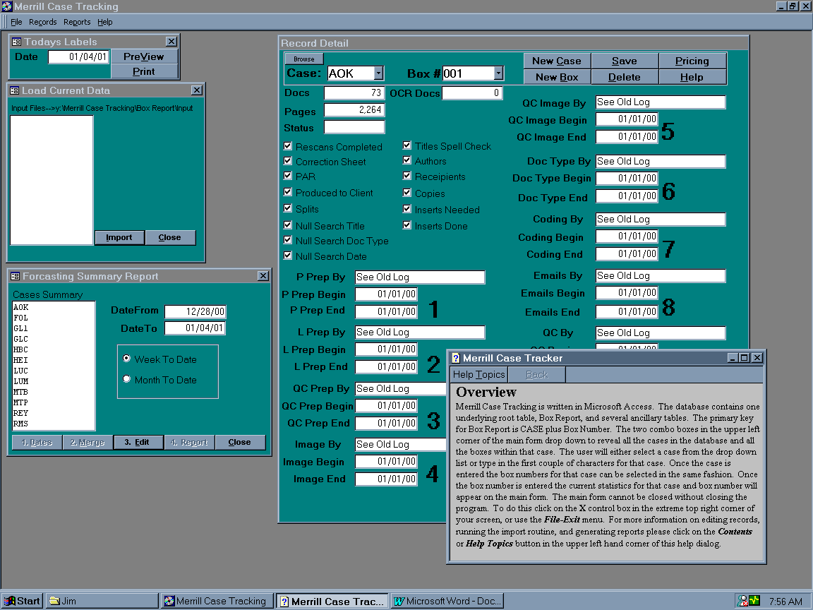
Merrill Case Tracking ScreenShot:

EFD Screenshot
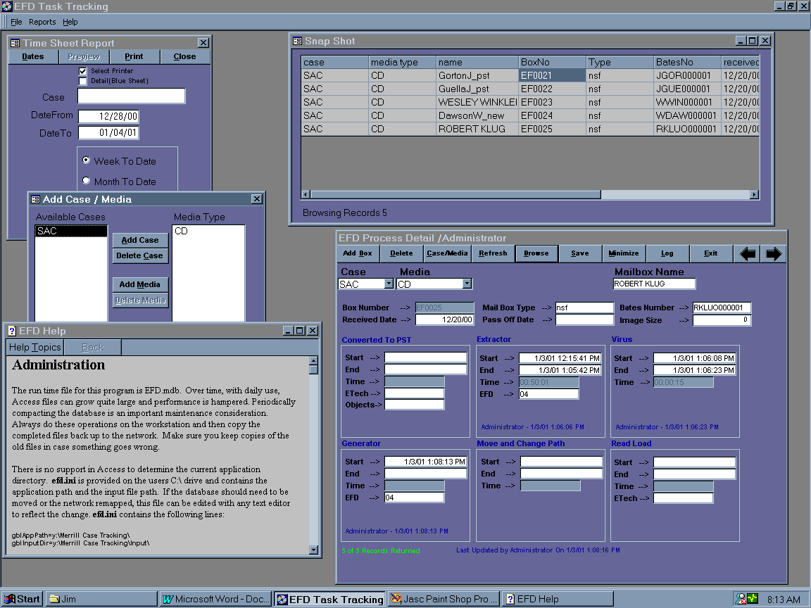
Relationships:
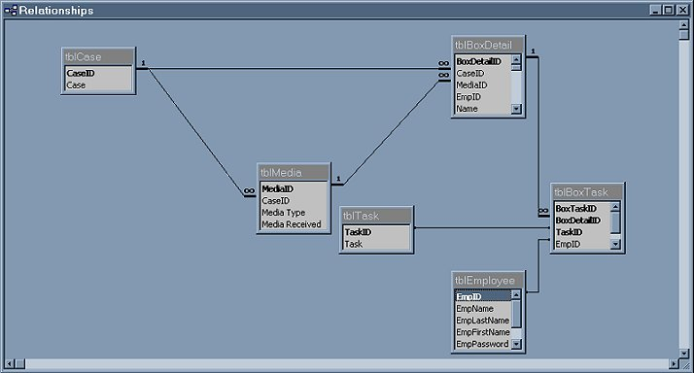

Sample SQL:
SELECT tblCase.case, tblBoxDetail.Name, tblBoxDetail.BoxNo, tblBoxDetail.[Converted to PST Time], tblBoxDetail.[Extractor Time], tblBoxDetail.[Virus Time], tblBoxDetail.[Generator Time], tblBoxDetail.[Move/Change Path Time], tblBoxDetail.[Read Load Time], tblboxdetail.[Received Date], tblBoxDetail.[Pass Off Date], tblemployee.empname, tbltask.task, tblboxtask.tasktime
FROM tblcase INNER JOIN (tblBoxDetail INNER JOIN (tblemployee INNER JOIN (tblboxtask INNER JOIN tbltask ON tblboxtask.taskid=tbltask.taskid) ON tblemployee.empid=tblboxtask.empid) ON tblboxdetail.boxdetailid=tblboxtask.boxdetailid) ON tblcase.caseid=tblboxdetail.caseid
WHERE iif((isnull([forms]![frmLogin]![txtparm]) or [forms]![frmLogin]![txtparm]=''),tblboxdetail.boxdetailid<>0,tblboxdetail.boxdetailid IN (select tblboxdetail.boxdetailid from tblboxdetail inner join tblcase on tblboxdetail.caseid=tblcase.caseid where tblcase.case=[forms]![frmLogin]![txtparm]));

Sample Code:
Option Compare Database
Option Explicit
Private rsMain As Recordset
Private rsTask As Recordset
Private mNewBox As Boolean
Private strCaseID$
Private strMediaID$

Private Sub Form_Load()
Set db = CurrentDb

cboCase.RowSource = "select distinct case from tblCase;"
lblRecs.Caption = ""
Me.MenuBar = "timesheet"
Me.Caption = "EFD Process Detail /" & gblUserName
cmdPrevious.Enabled = True
cmdNext.Enabled = False
cmdPrevious.Visible = False
cmdNext.Visible = False
cmdSave.Enabled = False
If gblUserName = "Administrator" Then
cmdCaseMedia.Enabled = True
End If

End Sub

Private Sub cboCase_AfterUpdate()
Dim rs As Recordset, strsql

Set rs = db.OpenRecordset("select caseid from tblCase where case='" & cboCase & "';", dbOpenDynaset, dbSeeChanges, dbOptimistic)
If Not rs.EOF Then
strCaseID = rs!caseId
End If

rs.Close
Set rs = Nothing
strsql = "select [media type] from tblmedia inner join tblcase on tblmedia.caseid=tblcase.caseid " & _
"where tblcase.case='" & cboCase & "';"
cboMedia = ""
Call ClearImage

cboMedia.RowSource = strsql

End Sub

Private Sub cboMedia_AfterUpdate()
Dim rs As Recordset, strsql$
strsql = "select mediaid from tblmedia where [media type]='" & cboMedia & "' and caseid=" & strCaseID & ";"
Set rs = db.OpenRecordset(strsql)
If Not rs.EOF Then
strMediaID = rs![mediaId]
End If

rs.Close
Set rs = Nothing

Call QueryForm

cmdSave.Enabled = True

End Sub

Private Sub cmdSave_Click()
If Me.NewBox Then
Call InsertRec
Else
Call SaveRecs
End If

End Sub

Private Sub cmdAddBox_Click()
Me.NewBox = True
Call ClearImage
txtBoxNumber.Enabled = True
cmdSave.Enabled = True
txtName.SetFocus
lblUpdate.Visible = False
lblFileMark.Caption = ""
cmdPrevious.Enabled = False
cmdNext.Enabled = False
End Sub

Private Sub cmdDeleteBox_Click()
Dim strsql
strsql = "delete from tblBoxDetail where boxdetailid=" & Me.Tag
db.Execute strsql, dbFailOnError + dbSeeChanges

Call QueryForm

End Sub

Private Sub cmdPrevious_Click()
If Not rsMain.BOF Then
lblFileMark.Caption = ""
lblUpdate.Visible = False
cmdNext.Enabled = True
rsMain.MovePrevious
lblRecs.Caption = (rsMain.AbsolutePosition + 1) & " of " & rsMain.RecordCount & " Records Returned"
If Not rsMain.BOF Then
lblFileMark.Caption = ""
lblUpdate.Visible = False
Call UpdateForm
Else
lblFileMark.Caption = "Beginning Of File"
lblRecs.Caption = ""
cmdNext.SetFocus
cmdPrevious.Enabled = False
Call ClearImage
End If
Else
lblFileMark.Caption = "Beginning Of File"
lblRecs.Caption = ""
cmdNext.SetFocus
cmdPrevious.Enabled = False
Call ClearImage
End If
End Sub

Private Sub cmdNext_Click()
If Not rsMain.EOF Then
lblFileMark.Caption = ""
lblUpdate.Visible = False
cmdPrevious.Enabled = True
rsMain.MoveNext
lblRecs.Caption = (rsMain.AbsolutePosition + 1) & " of " & rsMain.RecordCount & " Records Returned"
If Not rsMain.EOF Then
lblFileMark.Caption = ""
lblUpdate.Visible = False
Call UpdateForm
Else
lblFileMark.Caption = "End Of File"
lblRecs.Caption = ""
cmdPrevious.SetFocus
cmdNext.Enabled = False
Call ClearImage
End If
Else
lblFileMark.Caption = "End Of File"
lblRecs.Caption = ""
cmdPrevious.SetFocus
cmdNext.Enabled = False
Call ClearImage
End If
End Sub

Private Sub QueryForm()
Dim strsql$
strsql = "SELECT tblcase.caseid,tblCase.case,tblmedia.mediaid,tblmedia.[media type],tblEmployee.empid," & _
"tblemployee.empname,tblboxdetail.boxdetailid,tblboxdetail.empid as bempid," & _
"tblBoxDetail.Name,tblBoxDetail.BoxNo,tblBoxDetail.Type,tblBoxDetail.BatesNo," & _
"tblBoxDetail.[Converted to PST Start], tblBoxDetail.[Converted to PST End]," & _
"tblBoxDetail.[Converted to PST Time], tblBoxDetail.[Converted to PST ETech]," & _
"tblBoxDetail.[Converted to PST Objects], tblBoxDetail.[Extractor Start]," & _
"tblBoxDetail.[Extractor End], tblBoxDetail.[Extractor Time], tblBoxDetail.[Extractor EFD]," & _
"tblBoxDetail.[Virus Start], tblBoxDetail.[Virus End], tblBoxDetail.[Virus Time]," & _
"tblBoxDetail.[Generator Start], tblBoxDetail.[Generator End], tblBoxDetail.[Generator Time]," & _
"tblBoxDetail.[Generator EFD], tblBoxDetail.[Move/Change Path Start], tblBoxDetail.[Move/Change Path End]," & _
"tblBoxDetail.[Move/Change Path Time], tblBoxDetail.[Read Load Start], tblBoxDetail.[Read Load End]," & _
"tblBoxDetail.[Read Load Time], tblBoxDetail.[Read Load ETech],tblBoxDetail.[Received Date],tblBoxDetail.[Pass Off Date],tblBoxDetail.[Image Size]," & _
"tblboxdetail.[last update] " & _
"FROM (tblBoxDetail INNER JOIN tblEmployee on tblBoxDetail.empid=tblemployee.empid) " & _
"inner join (tblmedia inner join tblcase on tblmedia.caseid=tblcase.caseid) on tblboxdetail.mediaid=tblmedia.mediaid " & _
"WHERE " & IIf(IsNull(cboCase) Or cboCase = "", "tblcase.case<>'' and ", "tblcase.case='" & cboCase & "' and ") & _
IIf(IsNull(cboMedia) Or cboMedia = "", "(tblMedia.[media type]<>'' and tblmedia.mediaid=tblBoxDetail.mediaid)", "(tblmedia.[media type]='" & _
[Forms]![frmTimeSheet]![cboMedia] & "' and tblmedia.mediaID=tblBoxDetail.mediaid)") & ";"

Debug.Print strsql

Me.Tag = ""
Set rsMain = db.OpenRecordset(strsql, dbOpenDynaset, dbConsistent, dbOptimistic)
If Not rsMain.EOF Then
lblFileMark.Caption = ""
rsMain.MoveLast
' rsMain.MoveFirst
lblRecs.Caption = (rsMain.AbsolutePosition + 1) & " of " & rsMain.RecordCount & " Records Returned"
If rsMain.RecordCount > 1 Then
cmdPrevious.Visible = True
cmdNext.Visible = True
cmdNext.Enabled = True
End If
Call UpdateForm
Else
lblFileMark.Caption = "Empty Recordset"
lblRecs.Caption = "0 Records Returned"
lblLastUpdate.Caption = ""
cmdPrevious.Visible = False
cmdPrevious.Enabled = False
cmdNext.Visible = False
cmdNext.Enabled = False
Call ClearImage
End If
lblUpdate.Visible = False

End Sub

Private Function UpdateForm()
Dim strsql$

'recid
Me.Tag = rsMain!boxdetailid
lblLastUpdate.Caption = "Last Updated by " & rsMain!empname & " On " & rsMain![last update]

'task detail
strsql = "select tbltask.task,tblboxtask.tasktime,tblemployee.empname,tblboxtask.empid from tbltask " & _
"INNER JOIN (tblboxtask inner join tblemployee on tblboxtask.empid=tblemployee.empid) " & _
"on tbltask.taskid=tblboxtask.taskid " & _
"WHERE tblboxtask.boxdetailid=" & Me.Tag & ";"
Set rsTask = db.OpenRecordset(strsql, dbOpenDynaset, dbConsistent, dbOptimistic)
lblPST.Caption = ""
lblEXT.Caption = ""
lblVIR.Caption = ""
lblGEN.Caption = ""
lblPath.Caption = ""
lblReadLoad.Caption = ""

'general
txtName = rsMain!Name
txtBoxNumber = rsMain!BoxNo
txtType = rsMain!Type
txtBatesNumber = rsMain!BatesNo
txtRecvDate = rsMain![Received Date]
txtPassOffDate = rsMain![Pass Off Date]
txtImageSize = rsMain![Image Size]

'pst
txtPSTStart = rsMain![Converted to PST Start]
txtPSTEnd = rsMain![Converted to PST End]
txtPSTTime = ParseTime(DateDiff("s", txtPSTStart, txtPSTEnd))
txtPSTETech = rsMain![Converted to PST ETech]
txtPSTObjects = rsMain![Converted to PST Objects]
If Not rsTask.EOF Then
rsTask.MoveFirst
rsTask.FindFirst "task='Converted to PST'"
If Not rsTask.NoMatch Then
lblPST.Caption = rsTask!empname & " - " & rsTask!TaskTime
End If
End If

'extractor
txtExtStart = rsMain![Extractor Start]
txtExtEnd = rsMain![Extractor End]
txtExtTime = ParseTime(DateDiff("s", txtExtStart, txtExtEnd))
txtExtEFD = rsMain![Extractor EFD]
If Not rsTask.EOF Then
rsTask.MoveFirst
rsTask.FindFirst "task='Extractor'"
If Not rsTask.NoMatch Then
lblEXT.Caption = rsTask!empname & " - " & rsTask!TaskTime
End If
End If

'virus
txtVirusStart = rsMain![Virus Start]
txtVirusEnd = rsMain![Virus End]
txtVirusTime = ParseTime(DateDiff("s", txtVirusStart, txtVirusEnd))
If Not rsTask.EOF Then
rsTask.MoveFirst
rsTask.FindFirst "task='Virus'"
If Not rsTask.NoMatch Then
lblVIR.Caption = rsTask!empname & " - " & rsTask!TaskTime
End If
End If

'generator
txtGenStart = rsMain![Generator Start]
txtGenEnd = rsMain![Generator End]
txtGenTime = ParseTime(DateDiff("s", txtGenStart, txtGenEnd))
txtGenEFD = rsMain![Generator EFD]
If Not rsTask.EOF Then
rsTask.MoveFirst
rsTask.FindFirst "task='Generator'"
If Not rsTask.NoMatch Then
lblGEN.Caption = rsTask!empname & " - " & rsTask!TaskTime
End If
End If

'move and change path
txtMvChStart = rsMain![Move/Change Path Start]
txtMvChEnd = rsMain![Move/Change Path End]
txtMvChTime = ParseTime(DateDiff("s", txtMvChStart, txtMvChEnd))
If Not rsTask.EOF Then
rsTask.MoveFirst
rsTask.FindFirst "task='Move and Change Path'"
If Not rsTask.NoMatch Then
lblPath.Caption = rsTask!empname & " - " & rsTask!TaskTime
End If
End If

'read load
txtReadLoadStart = rsMain![Read Load Start]
txtReadLoadEnd = rsMain![Read Load End]
txtReadLoadTime = ParseTime(DateDiff("s", txtReadLoadStart, txtReadLoadEnd))
txtReadLoadETech = rsMain![Read Load ETech]
If Not rsTask.EOF Then
rsTask.MoveFirst
rsTask.FindFirst "task='Read Load'"
If Not rsTask.NoMatch Then
lblReadLoad.Caption = rsTask!empname & " - " & rsTask!TaskTime
End If
End If

Me.Refresh

End Function

Private Function SaveRecs()
On Error GoTo errhdl

rsMain.Edit

'general
rsMain!bempid = gblUserID
rsMain!Name = txtName
rsMain!BoxNo = txtBoxNumber
rsMain!Type = txtType
rsMain!BatesNo = txtBatesNumber
rsMain![Received Date] = txtRecvDate
rsMain![Pass Off Date] = txtPassOffDate
rsMain![last update] = Now()

'pst
rsMain![Converted to PST Start] = IIf(txtPSTStart = "", "Null", txtPSTStart)
rsMain![Converted to PST End] = IIf(txtPSTEnd = "", "Null", txtPSTEnd)
rsMain![Converted to PST Time] = txtPSTTime
rsMain![Converted to PST ETech] = txtPSTETech
rsMain![Converted to PST Objects] = txtPSTObjects

'extractor
rsMain![Extractor Start] = IIf(txtExtStart = "", "Null", txtExtStart)
rsMain![Extractor End] = IIf(txtExtEnd = "", "Null", txtExtEnd)
rsMain![Extractor Time] = txtExtTime
rsMain![Extractor EFD] = txtExtEFD

'virus
rsMain![Virus Start] = IIf(txtVirusStart = "", "Null", txtVirusStart)
rsMain![Virus End] = IIf(txtVirusEnd = "", "Null", txtVirusEnd)
rsMain![Virus Time] = txtVirusTime

'generator
rsMain![Generator Start] = IIf(txtGenStart = "", "Null", txtGenStart)
rsMain![Generator End] = IIf(txtGenEnd = "", "Null", txtGenEnd)
rsMain![Generator Time] = txtGenTime
rsMain![Generator EFD] = txtGenEFD

'move and change path
rsMain![Move/Change Path Start] = IIf(txtMvChStart = "", "Null", txtMvChStart)
rsMain![Move/Change Path End] = IIf(txtMvChEnd = "", "Null", txtMvChEnd)
rsMain![Move/Change Path Time] = txtMvChTime

'read load
rsMain![Read Load Start] = IIf(txtReadLoadStart = "", "Null", txtReadLoadStart)
rsMain![Read Load End] = IIf(txtReadLoadEnd = "", "Null", txtReadLoadEnd)
rsMain![Read Load Time] = txtReadLoadTime
rsMain![Read Load ETech] = txtReadLoadETech

rsMain.Update
lblLastUpdate.Caption = "Last Updated by " & rsMain!empname & " On " & rsMain![last update]
Exit Function

errhdl:
Select Case Err
Case 3021
MsgBox "You Must First Click Add Box", vbInformation, Err.Description
Case Else
MsgBox Err.Description, vbCritical, Err
End Select
End Function

Private Sub InsertRec()
Dim strsql$, rs As Recordset

On Error GoTo errhdl:

If strCaseID = "" Or strMediaID = "" Then
MsgBox "You Must Select a Case and Media Type Before Adding a Box", vbExclamation, "Missing Keys"
Exit Sub
End If

strsql = "insert into tblboxdetail (caseid,mediaid,empid,name,boxno,type,batesno,[converted to pst start]," & _
"[converted to pst end],[Converted to PST Time],[Converted to PST ETech],[Converted to PST Objects]," & _
"[Extractor Start],[Extractor End],[Extractor Time],[Extractor EFD],[Virus Start],[Virus End]," & _
"[Virus Time],[Generator Start],[Generator End],[Generator Time],[Generator EFD],[Move/Change Path Start]," & _
"[Move/Change Path End],[Move/Change Path Time],[Read Load Start],[Read Load End],[Read Load Time]," & _
"[Read Load ETech],[Received Date],[Pass Off Date]) " & _
"VALUES (" & strCaseID & "," & strMediaID & ",'" & gblUserID & "','" & txtName & "','" & txtBoxNumber & "','" & txtType & _
"','" & txtBatesNumber & "'," & IIf(txtPSTStart = "", "Null", "#" & txtPSTStart & "#") & "," & IIf(txtPSTEnd = "", "Null", "#" & txtPSTEnd & "#") & _
",'" & txtPSTTime & "','" & txtPSTETech & "','" & txtPSTObjects & "'," & IIf(txtExtStart = "", "Null", "#" & txtExtStart & "#") & _
"," & IIf(txtExtEnd = "", "Null", "#" & txtExtEnd & "#") & ",'" & txtExtTime & "','" & txtExtEFD & "'," & IIf(txtVirusStart = "", "Null", "#" & txtVirusStart & "#") & _
"," & IIf(txtVirusEnd = "", "Null", "#" & txtVirusEnd & "#") & ",'" & txtVirusTime & "'," & IIf(txtGenStart = "", "Null", "#" & txtGenStart & "#") & _
"," & IIf(txtGenEnd = "", "Null", "#" & txtGenEnd & "#") & ",'" & txtGenTime & "','" & txtGenEFD & _
"'," & IIf(txtMvChStart = "", "Null", "#" & txtMvChStart & "#") & "," & IIf(txtMvChEnd = "", "Null", "#" & txtMvChEnd & "#") & _
",'" & txtMvChTime & "'," & IIf(txtReadLoadStart = "", "Null", "#" & txtReadLoadStart & "#") & _
"," & IIf(txtReadLoadEnd = "", "Null", "#" & txtReadLoadEnd & "#") & ",'" & txtReadLoadTime & _
"','" & txtReadLoadETech & "'," & IIf(txtRecvDate = "", "Null", "#" & txtRecvDate & "#") & _
"," & IIf(txtPassOffDate = "", "Null", "#" & txtPassOffDate & "#") & ");"

'Debug.Print strsql

db.Execute strsql, dbFailOnError + dbSeeChanges

If db.RecordsAffected <> 0 Then
lblUpdate.Visible = True
Me.NewBox = False
txtBoxNumber.Enabled = False
cmdPrevious.Enabled = True
cmdNext.Enabled = True
End If

Call QueryForm

Exit Sub

errhdl:
Select Case Err
Case 3315
MsgBox "You Must Enter the Box Number at a Minimum", vbInformation, "No Fields to Save"
txtBoxNumber.SetFocus
Case Else
MsgBox Err.Description, vbCritical, Err
End Select
End Sub

Private Sub ClearImage()
Dim ctl As Control

For Each ctl In Me.Controls
If TypeName(ctl) = "Textbox" Then
If ctl.Enabled = True Then
ctl = ""
Else
ctl.Enabled = True
ctl = ""
ctl.Enabled = False
End If
ElseIf TypeName(ctl) = "Checkbox" Then
If ctl.Enabled = True Then
ctl = False
End If
ElseIf TypeName(ctl) = "Label" Then
If ctl.Tag = True Then
ctl.Caption = ""
End If
End If
Next

End Sub

Private Function ParseTime(secs) As String
Dim hours As Long
Dim minutes As Long
Dim seconds As Long
Dim tempstr$

If IsNull(secs) Then Exit Function

If secs >= 3600 Then
hours = CInt(secs / 3600)
minutes = CInt(secs - (hours * 3600)) / 60
seconds = secs Mod 60
ElseIf secs >= 60 Then
minutes = CInt(secs / 60)
seconds = secs Mod 60
Else
minutes = 0
seconds = secs
End If
tempstr = IIf(hours < 10, "0" & CStr(hours), CStr(hours)) & ":" & _
IIf(minutes < 10, "0" & CStr(minutes), CStr(minutes)) & ":" & _
IIf(seconds < 10, "0" & CStr(seconds), CStr(seconds))

ParseTime = tempstr

End Function

Public Property Let NewBox(bValue As Boolean)
mNewBox = bValue
End Property

Public Property Get NewBox() As Boolean
NewBox = mNewBox
End Property

Private Sub txtPSTStart_MouseDown(Button As Integer, Shift As Integer, x As Single, Y As Single)
If Me.NewBox Or Me.Tag = "" Then
MsgBox "Please Save the New Record Before Entering Time Information", vbInformation, "Missing Key"
Exit Sub
End If
If Button = 2 Then
txtPSTStart = Now()
Call txtPSTStart_AfterUpdate
End If
End Sub

Private Sub txtPSTStart_AfterUpdate()
Call UpdateTask("Pst")
If txtPSTEnd = "" Then Exit Sub
txtPSTTime = ParseTime(DateDiff("s", txtPSTStart, txtPSTEnd))
End Sub

Private Sub UpdateTask(strTask$)
Dim strsql$
Select Case strTask
Case "Pst"
If rsTask.EOF Then
strsql = "insert into tblboxtask (boxdetailid,taskid,empid) values (" & _
Me.Tag & "," & 1 & ",'" & gblUserID & "');"
db.Execute strsql
Else
rsTask.MoveFirst
rsTask.FindFirst "task='Converted to PST'"
If Not rsTask.NoMatch Then
rsTask.Edit
rsTask!empid = gblUserID
rsTask!TaskTime = Now()
rsTask.Update
Else
strsql = "insert into tblboxtask (boxdetailid,taskid,empid) values (" & _
Me.Tag & "," & 1 & ",'" & gblUserID & "');"
db.Execute strsql
End If
End If
Case "Ext"
If rsTask.EOF Then
strsql = "insert into tblboxtask (boxdetailid,taskid,empid) values (" & _
Me.Tag & "," & 2 & ",'" & gblUserID & "');"
db.Execute strsql
Else
rsTask.MoveFirst
rsTask.FindFirst "task='Extractor'"
If Not rsTask.NoMatch Then
rsTask.Edit
rsTask!empid = gblUserID
rsTask!TaskTime = Now()
rsTask.Update
lblEXT.Caption = rsTask!empname & " - " & rsTask!TaskTime
Else
strsql = "insert into tblboxtask (boxdetailid,taskid,empid) values (" & _
Me.Tag & "," & 2 & ",'" & gblUserID & "');"
db.Execute strsql
End If
End If
Case "Virus"
If rsTask.EOF Then
strsql = "insert into tblboxtask (boxdetailid,taskid,empid) values (" & _
Me.Tag & "," & 3 & ",'" & gblUserID & "');"
db.Execute strsql
Else
rsTask.MoveFirst
rsTask.FindFirst "task='Virus'"
If Not rsTask.NoMatch Then
rsTask.Edit
rsTask!empid = gblUserID
rsTask!TaskTime = Now()
rsTask.Update
Else
strsql = "insert into tblboxtask (boxdetailid,taskid,empid) values (" & _
Me.Tag & "," & 3 & ",'" & gblUserID & "');"
db.Execute strsql
End If
End If
Case "Gen"
If rsTask.EOF Then
strsql = "insert into tblboxtask (boxdetailid,taskid,empid) values (" & _
Me.Tag & "," & 4 & ",'" & gblUserID & "');"
db.Execute strsql
Else
rsTask.MoveFirst
rsTask.FindFirst "task='Generator'"
If Not rsTask.NoMatch Then
rsTask.Edit
rsTask!empid = gblUserID
rsTask!TaskTime = Now()
rsTask.Update
Else
strsql = "insert into tblboxtask (boxdetailid,taskid,empid) values (" & _
Me.Tag & "," & 4 & ",'" & gblUserID & "');"
db.Execute strsql
End If
End If
Case "Path"
If rsTask.EOF Then
strsql = "insert into tblboxtask (boxdetailid,taskid,empid) values (" & _
Me.Tag & "," & 5 & ",'" & gblUserID & "');"
db.Execute strsql
Else
rsTask.MoveFirst
rsTask.FindFirst "task='Move and Change Path'"
If Not rsTask.NoMatch Then
rsTask.Edit
rsTask!empid = gblUserID
rsTask!TaskTime = Now()
rsTask.Update
Else
strsql = "insert into tblboxtask (boxdetailid,taskid,empid) values (" & _
Me.Tag & "," & 5 & ",'" & gblUserID & "');"
db.Execute strsql
End If
End If
Case "Read Load"
If rsTask.EOF Then
strsql = "insert into tblboxtask (boxdetailid,taskid,empid) values (" & _
Me.Tag & "," & 6 & ",'" & gblUserID & "');"
db.Execute strsql
Else
rsTask.MoveFirst
rsTask.FindFirst "task='Read Load'"
If Not rsTask.NoMatch Then
rsTask.Edit
rsTask!empid = gblUserID
rsTask!TaskTime = Now()
rsTask.Update
Else
strsql = "insert into tblboxtask (boxdetailid,taskid,empid) values (" & _
Me.Tag & "," & 6 & ",'" & gblUserID & "');"
db.Execute strsql
End If
End If
End Select

Call SaveRecs
Call UpdateForm

End Sub

Private Sub cmdBrowse_Click()
Dim strsql$
'If IsNull(cboCase) Or cboCase = "" Then
' MsgBox "Pleae Select a Case For the Browse", vbExclamation, "Missing Filter"
' Exit Sub
'End If
strsql = "SELECT tblcase.case,tblmedia.[media type],tblboxdetail.name,tblBoxDetail.BoxNo, tblBoxDetail.Type," & _
"tblBoxDetail.BatesNo,tblboxdetail.[received date],tblboxdetail.[pass off date],tblboxdetail.[last update]," & _
"tblemployee.empname " & _
"FROM (tblBoxDetail INNER JOIN tblEmployee on tblBoxDetail.empid=tblemployee.empid) " & _
"inner join (tblmedia inner join tblcase on tblmedia.caseid=tblcase.caseid) on tblboxdetail.mediaid=tblmedia.mediaid;"

gblBrowseSQL = strsql
DoCmd.OpenForm "frmBrowse", acNormal
DoEvents
End Sub
Private Sub Form_Unload(Cancel As Integer)
Dim strsql$
strsql = "update tblemployee set emploggedin=false where empid='" & gblUserID & "';"
db.Execute strsql, dbFailOnError + dbSeeChanges
Set rsMain = Nothing
End Sub
Private Sub ImportCases()

Dim file$, strin$, strBox$, strDocs$, strOCRDocs$, strPages$
Dim hFile%, X%, caseId$, strFind$, intRecsRead%, intRecsAdded%, intRecsUpdated%
Dim rs As Recordset
Dim aCodes() As String

'MsgBox gblInputDir & "???report.txt"
Set db = CurrentDb
Set rs = db.OpenRecordset("select case,[box number],docs,OCRDocs,pages from [box report];")

If Not rs.EOF Then rs.MoveLast

'***************
file = Dir$(gblInputDir & "*report.txt")
ReDim Preserve aCodes(1)
aCodes(1) = file
ReDim Preserve aCodes(UBound(aCodes) + 1)

Do While file$ <> ""
file = Dir
aCodes(UBound(aCodes)) = file
ReDim Preserve aCodes(UBound(aCodes) + 1)
Loop
'***************
guaProgress.Max = UBound(aCodes)

file = Dir$(gblInputDir & "*report.txt")
Do While file$ <> ""
caseId = Left(file, 3)
hFile = FreeFile
Open (gblInputDir & file) For Input As hFile
For X = 1 To 2
Line Input #hFile, strin
Next X
Do While Not EOF(hFile)
Line Input #hFile, strin
' box cut
If Left$(strin, 7) = Chr$(10) & "Report" Then Exit Do
If Left$(strin, 8) = Chr$(10) & Chr$(10) & "Report" Then Exit Do

intRecsRead = intRecsRead + 1
lblRecsRead.Caption = "Records Read =" & intRecsRead
DoEvents

strBox = Mid$(strin, 1, InStr(1, strin, " ") - 1)
strin = Mid$(strin, Len(strBox) + 1, Len(strin) - Len(strBox))
For X = 1 To Len(strin)
If Left(strin, 1) = " " Then
strin = Mid$(strin, 2, Len(strin) - 1)
Else
Exit For
End If
Next X
If Left$(strBox, 1) = Chr$(10) Then
strBox = Right(strBox, Len(strBox) - 1)
End If
' doc cut
strDocs = Mid$(strin, 1, InStr(1, strin, " ") - 1)
strin = Mid$(strin, Len(strDocs) + 1, Len(strin) - Len(strDocs))
For X = 1 To Len(strin)
If Left(strin, 1) = " " Then
strin = Mid$(strin, 2, Len(strin) - 1)
Else
Exit For
End If
Next X
' ocrdoc cut
If Len(strin) > 0 Then 'I hope this works,its not in the imput file at time of this writing
strOCRDocs = Mid$(strin, 1, InStr(1, strin, " ") - 1)
strin = Mid$(strin, Len(strOCRDocs) + 1, Len(strin) - Len(strOCRDocs))
For X = 1 To Len(strin)
If Left(strin, 1) = " " Then
strin = Mid$(strin, 2, Len(strin) - 1)
Else
Exit For
End If
Next X
End If
' page cut
strPages = Mid$(strin, 1, InStr(1, strin, " ") - 1)
strin = Mid$(strin, Len(strPages) + 1, Len(strin) - Len(strPages))
For X = 1 To Len(strin)
If Left(strin, 1) = " " Then
strin = Mid$(strin, 2, Len(strin) - 1)
Else
Exit For
End If
Next X

Debug.Print caseId & "***" & strBox & "***" & strOCRDocs & "***" & strDocs & "***" & strPages & "***"

If Not rs.EOF Then rs.MoveFirst
strFind = "Case = '" & caseId & "' and [box number]='" & strBox & "'"
rs.FindFirst strFind
If rs.NoMatch Then 'thers no match, its new
intRecsAdded = intRecsAdded + 1
lblRecsAdded.Caption = "Records Added =" & IIf(intRecsAdded > 0, intRecsAdded, "0")
DoEvents
rs.AddNew
rs!Case = caseId
rs![Box Number] = strBox
rs!Docs = strDocs
rs!ocrDocs = strOCRDocs
rs!Pages = strPages
rs.Update
Else 'its already in the database just update
intRecsUpdated = intRecsUpdated + 1
lblRecsUpdated.Caption = "Records Updated=" & IIf(intRecsUpdated > 0, intRecsUpdated, "0")
DoEvents
rs.Edit
rs!Docs = strDocs
rs!ocrDocs = strOCRDocs
rs!Pages = strPages
rs.Update
End If
Loop
txtImport = txtImport & file & vbCrLf
Close #hFile
file = Dir
guaProgress.value = guaProgress.value + 1
DoEvents
Loop

rs.Close
Set rs = Nothing

End Sub

